TITANIC
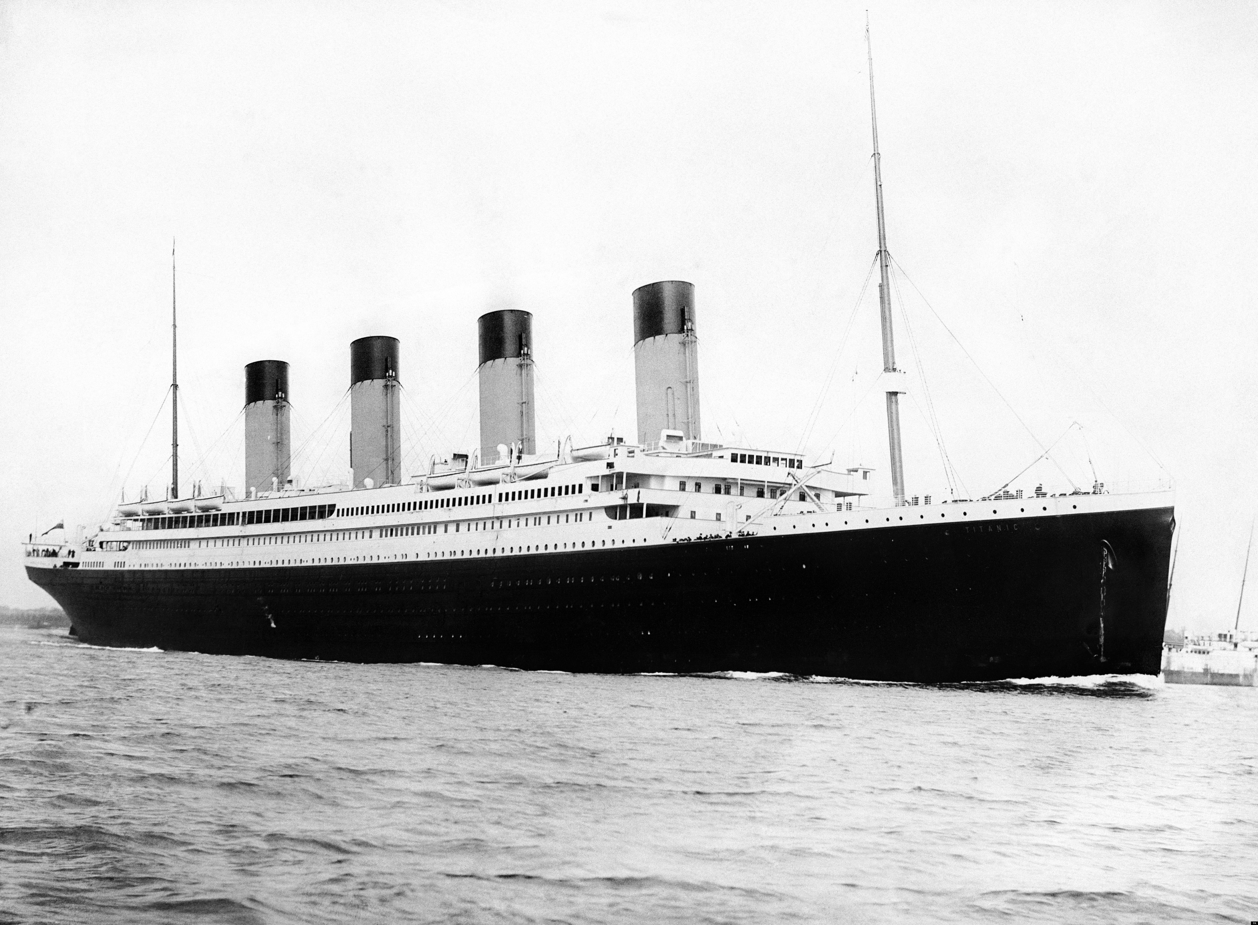
Summary

A team of marine archaeologists are aboard their specially equipped research ship, two miles above the wreck of RMS Titanic.

After an initial exploratory dive, using unmanned submersibles, the team make a final check of their equipment and discuss the operational parameters of their mission.

Under commission from the British Museum, the team’s objective is to explore the wreck as sensitively as possible and find personal objects that can be used in an exhibition to tell the forgotten stories of those involved in the disaster.

Overview of learning

What I want the students to learn
Knowledge
- A study of an aspect or theme in British history that extends pupils’ chronological knowledge beyond 1066, representing a significant turning point in British history.
- The ship (its construction, voyage, crew, ownership, history);
- Its cultural significance (iconic status, representation of Edwardian society, art, architecture, class, confidence in engineering and science);
- The story of the disaster (events, causes, repercussions, effects).
Skills
- Ask perceptive questions
- Think critically
- Weigh evidence
- Sift arguments
- Develop perspective and judgement.
Understanding
- Edwardian society was deeply stratified and resulted in an unnecessarily high number of casualties among the lower class passengers.
- The role hubris played in the disaster - over-confidence in the design of the ship, the superiority of engineering over nature, the urgency to break the record for crossing the Atlantic.
- The role human error and lack of planning played in the disaster - the shortage of life-boats, the loss of the key to locker holding the binoculars, a mistake by the steersman, the use of low-grade iron rivets.
- The effect the disaster had on Edwardian society and what it represented as a metaphor for the decline of Victorianism.
Social
- Work together effectively in small and large groups.
- Share ideas and listen to others.
- Explore different points of view.
- Evaluate own work and the work of others, give feedback and make suggestions for improvement.
- Draft, redraft, and produce work of high quality for others to learn about the context.

What’s interesting about this theme?

What’s interesting about this theme
For the students:
- The disaster – the events surrounding the sinking: the iceberg, the captain, the crew, the band, the SOS, the lack of life-boats, ‘women and children first’, and passengers.
- Events leading up to the disaster – the speed of the ship (trying to break the record), the unusually low path of the iceberg, the lack of binoculars, and the unawareness of the passengers.
- Events after the disaster – the time it took for other ships to arrive, people pulled from the sea, what happened to the people who survived, how was the disaster reported, the inquiry, and responsibility.
- The ship - its construction, size, fixtures and fittings, design, statistics, and different decks for different classes of passenger.

For the teacher:
- All of the above, and…
- The survival rates of people from different classes, the lessons learned from the disaster, the effect it had on those who designed, built, and commissioned the ship.
- How ship design changed after the disaster, how the disaster affected confidence in engineering.
- How the disaster became a metaphor for the decline of Victorianism and part of a narrative, culminating in WW1.

Inquiry Questions:

Step Four – Inquiry Questions
Social: How was life onboard the Titanic and the disaster affected by class and social attitudes?

Political: What effect did wealth, influence and social attitudes have the consequences of the disaster and the subsequent inquest?

Historical: How can we learn about the sinking of the Titanic and life in 1912 by studying historical artefacts from the wreck?

Environmental: What effects did the especially cold weather and the unusual ice-flow have of the disaster?

Critical: Could the disaster have been avoided? Was anyone to blame?

Ethical: Is it ethical to take artefacts from the wreck of the Titanic? Should these objects be considered the property of the victim’s families?

Philosophical: To what extent was the Titanic disaster the result of hubris?

Spiritual: Should the wreck of the Titanic be considered a gravesite? What are the Team’s responsibilities to the dead?

CONTEXT

Tension

Levels of Tension
Level | Examples from the Titanic
Level 1 Danger named but not controllable – possibly sudden and unexpected - Sudden obstacles, threats and watchers. Such as: drops (cliff, chasm etc), fires, Gods, witches, sentries, and other un-benign presences. | The iceberg
Level 2 Dangers known in advance – expected and planned for - A mission in face of danger that could involve the elements (cold, heat etc), enemies, and/or defences. This might involve being in a place, which is forbidden or difficult to reach. | - Field of icebergs  - Storms at sea.  - The pressure of the deep sea.  - The extreme cold.
Level 3 Duty in the face of distraction - Situations/territories that daunt, and might have unpredictable challenges and properties, but must be faced nevertheless. | - Captain Smith staying on deck as the ship sinks.  - The band playing on.  - The crew helping people onto the lifeboats.
Level 4 Herculean tasks - Extremely difficult or dangerous tasks requiring enormous effort. | - Saving the passengers  - Raising the artefacts from the wreck.  - Third class passengers finding a way up to the lifeboats.  - Working on the wreck without destroying it.
Level 5 Dangers from guile, untruths and exaggerations - Being spied on, tricked, lied to, or confused - deliberately or as a result of exaggeration. | - Newspaper reports claiming the Titanic was unsinkable and gave the passengers and crew an unrealistic (and dangerous) confidence in ship’s invulnerability.
Level 6 Threats from stupidity and lack of thought - Any thoughtless or foolish acts that result in an unintended outcome. Carelessness, wrong thinking, and/or losing or forgetting critical information etc. | - Not providing the lookouts with binoculars, while all the officers carried a pair.  - Halving the number of lifeboats because the owner thought they cluttered the First Class deck.  - Only half filling some of the lifeboats because of the ‘women and children first’ rule.
Level 7 Pressures from limitations in time - Anything that limits activity. Means an activity must be completed within a certain time or where someone must be with someone or somewhere by a certain time. | - Rescuing people before the ship sinks.  - Lifting the artefacts from the ocean before they decay.  - Preparing the exhibition ready for the opening day.
Level 8 Pressures from illness, weakness and vulnerability - Difficulties created by wounds, accidents, illness, old age or young age. | - Passengers and crew injured or sick.  - Rescuing people from the freezing sea.
Level 9 Breaks in communication - Failure of messages reaching their destination, technical problems. Lights failing, batteries running low, poor reception, burnt letters, messenger being killed or injured. | - The Marconi operators not passing on the iceberg warnings because they were too busy sending and receiving personal messages from the passengers.
Level 10 Missing, lost or misreading signs - Misunderstood signs, messages or signals and missing signs. | - Lack of urgency among the passengers during the evacuation who misread the tilt of the ship as a sign that it would take many hours to sink.  - The California (a ship close by that could have saved many of the victims of the disaster) misreading the distress flares as fireworks.
Level 11 Breakdowns in relations and differences - People falling out with one another, especially friends, family and work colleagues. | - Some members of the crew failing to follow the orders of the officers.  - The families of the victims and the survivors asking for an inquiry into the role of the White Star Line in the disaster and being refused access to the owners.
Level 12 Loss of faith in companions and beliefs - People who where once trusted but betrayed a person’s faith. (The husband caught having an affair). Can include ideas and beliefs. (The priest who no longer believes). | - The loss of faith felt by society in the infallibility of science and technology after the sinking of the Titanic.

Location

Theme | Location | Aspects to be decided
Titanic | The wreck of the ship on the ocean floor, beginning to rot and decay. | How the wreck is distributed across the sea-bed (based on real historical information); the artefacts discovered by the archaeologists; the stories behind the artefacts.

Time

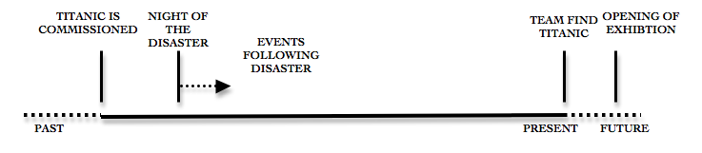

Expert Team

Team Marine Archaeologists
Qualities
Powers:
- Decide on the use of equipment, times for diving and how long, whether it is safe to dive (especially in regards to the weather), and how the job should be done (organising: time, layout, order, etc).
- Influence: how the artefacts are displayed, how they will tell the story of the ship, and how the relatives of those who died and survived should be involved in the project.
Responsibilities:
- To the careful preservation of the artefacts and the wreck, the memory of those people who died in the disaster, the facts and the accuracy of the history, the careful maintenance of the equipment, and the safety of other members of the Team.
Values:
- To preserve and protect marine archaeology, educate and inform, make maritime archaeology more accessible to the general public.

Client

Client: British Museum
A high authority client who expects high standards and has the power to terminate the commission. The Team communicate with the Client through an intermediary acting on the museum’s behalf. Most of the communication is done via email and ship-to-shore video-calls.

Commission

Commission
“To explore the wreck as sensitively as possible and find personal objects that can be used in an exhibition to tell the forgotten stories of people involved in the disaster.”

There are three elements to this commission:

- To ‘sensitively’ explore the wreck – This is something the Team will decide for themselves as they work on the Commission.
- To ‘find personal objects’ – This is a task for the students to complete outside the fiction. Using their imagination and developing knowledge of the context they will create the different objects found by the Team. (See the planning on page # in the next chapter).
- To use these objects ‘in an exhibition to tell the forgotten stories of people involved in the disaster.’ The most challenging of the three elements that demands a lot from the students in terms of their understanding and their skills in communicating knowledge. They are likely to need a considerable amount of help and support from the teacher.

Other points of view

Other Points of View
Present day:
- The Expert Team: Marine Archaeologists
- The Client: The British Museum
- The Client’s representative: Professor Brown, manager of the project
- The Press covering the story - newspapers, TV, and online
- The relatives of those who were on the ship
- Other historians and interested parties

The past:
- The passengers
- The crew
- The captain
- The families of those on board
- The ship’s owners
- The newspapers that covered the story
- The rescuers
- The survivors

ACTIVITIES AND CURRICULUM LINKS

Tasks and Activities

Tasks and Activities Grid
Division | Category and Task | Activity and Purpose | Curriculum
Material Resources | Places - Maps | Students create maps of the wreck for the marine archaeology team | Geography
Social, cultural, historical dimensions | Safety procedures | Students create plans and routines for working in submersibles, including evacuation plans in case of emergency. | English - writing
Interactions with people outside the Team | Briefing for the press | Students create a short presentation for the press visiting the site explaining the excavation and what has been found. | English
Interactions with people inside the Team | Researching and presenting information | Students use books, the Internet, and other media to research the history of the Titanic and artefacts. | History

Curriculum

Subjects | Curriculum
History | This is a ‘depth’ study from the unit: An aspect or theme in British history that extends chronological knowledge beyond 1066  - Ask perceptive questions, think critically, weigh evidence, sift arguments, and develop perspective and judgement.  - Understand historical concepts and use them to make connections, draw contrasts, analyse trends, frame historically valid questions and create their own structured accounts, including written narratives and analyses  - Understand the methods of historical enquiry, including how evidence is used rigorously to make historical claims, and discern how and why contrasting arguments and interpretations of the past have been constructed.  - Gain historical perspective by placing their growing knowledge into different contexts.  - Develop a chronologically secure knowledge and understanding of British, local and world history, establishing clear narratives within and across the period.  - Note connections, contrasts and trends over time and develop the appropriate use of historical terms.  - Address and devise historically valid questions about change, cause, similarity and difference, and significance.  - Construct informed responses that involve thoughtful selection and organisation of relevant historical information.  - Understand how our knowledge of the past is constructed from a range of sources.
English | Writing - Composition  Plan writing by:  - identifying audience and purpose of the writing, selecting appropriate form  - noting and developing initial ideas, drawing on reading and research  Draft and write by:  - selecting appropriate grammar and vocabulary, understanding how such choices can change and enhance meaning  - describing settings, characters and atmosphere and integrating dialogue  - using a wide range of devices to build cohesion within and across paragraphs  - using further organisational and presentational devices to structure text and to guide the reader [for example, headings, bullet points, underlining]  Evaluate and edit by:  - assessing the effectiveness of their own and others’ writing  - proposing changes to vocabulary, grammar and punctuation to enhance effects and clarify meaning  - ensuring the consistent and correct use of tense throughout a piece of writing  - ensuring correct subject and verb agreement when using singular and plural, distinguishing between the language of speech and writing and choosing the appropriate register  Proof-read for spelling and punctuation errors  Perform own compositions, using appropriate intonation, volume, and movement so that meaning is clear.
Science | Forces  - Explain that unsupported objects fall towards the Earth because of the force of gravity acting between the Earth and the falling object  - Identify effects of air resistance, water resistance & friction, that act between moving surfaces  - Recognise that some mechanisms, including levers, pulleys and gears, allow a smaller force to have a greater effect.
Art & Design | - Produce creative work, exploring their ideas and recording their experiences  - Become proficient in drawing, painting, sculpture and other art, craft and design techniques  - Evaluate and analyse creative works using the language of art, craft and design  - Know about great artists, craft makers and designers, and understand the historical and cultural development of their art forms.
Computing | - Are competent, confident & creative users of information and communication technology.
Design & Technology | - Build and apply a repertoire of knowledge, understanding and skills in order to design and make high-quality prototypes and products for a wide range of users  - Critique, evaluate and test their ideas and products and the work of others
Geography | - Use maps, atlases, globes and digital/computer mapping to locate countries and describe features studied  - Use the eight points of a compass, four and six-figure grid references, symbols and key

THE START

Step 1. Introducing the context
Strategy: 2 - Sharing a partial narrative selected in advance.
Key planning aspects: 1 - What’s happening (location, people, events); 2 - ‘Signs’ for the students to interpret; 3 - Something to attract their interest (tension); 4 - Inquiry questions.
Description: The students are introduced to the context using two pictures prepared in advance. The first is a lifebuoy from the Titanic with the name of the ship removed. The second is the lifebuoy with the name returned. The purpose is to engage the students in a conversation about the ship and the events of the disaster.
[i] Bring the students into a circle. Show them the picture of the lifebuoy without the name on and put it in the centre of the circle.
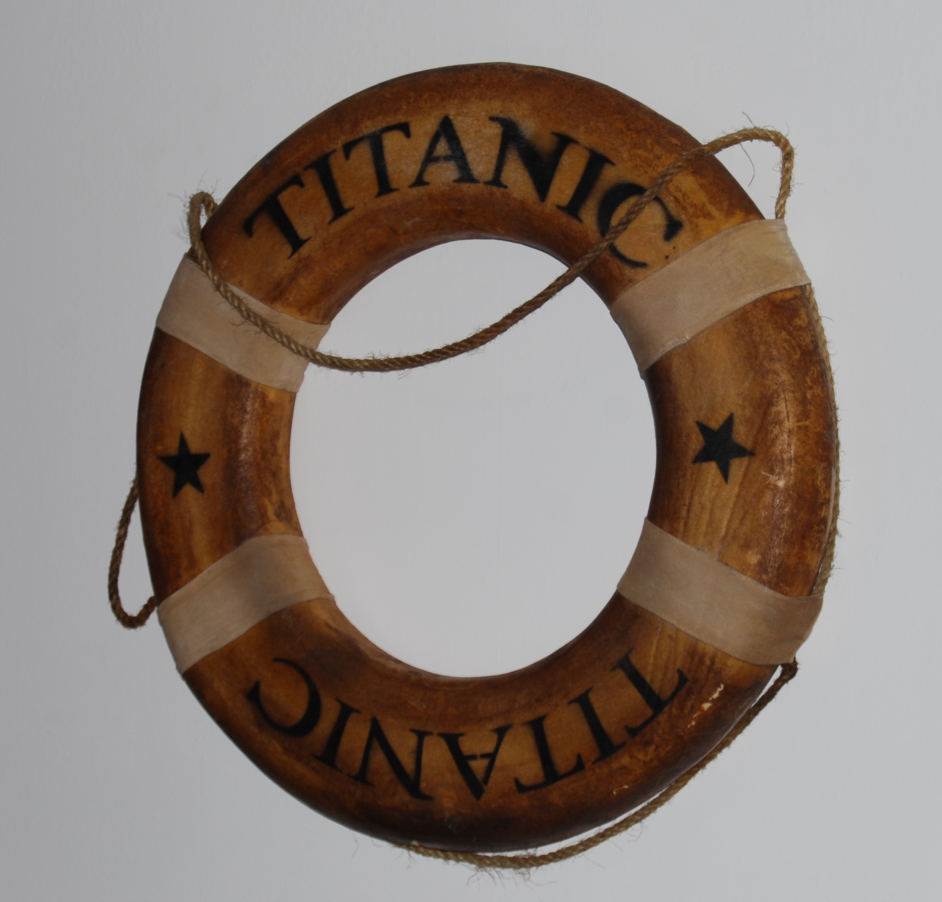
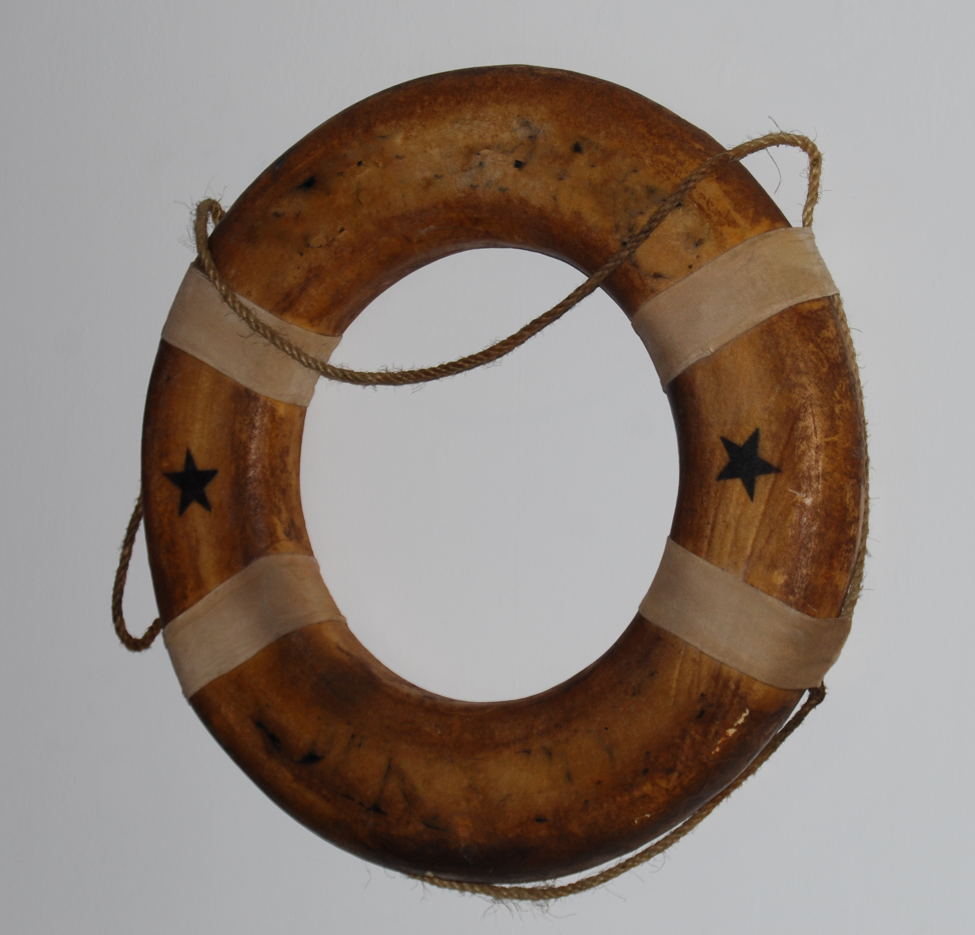

“I’d like to show you something… what does it make you think of?”

[Give the students chance to think and talk. They might mention the Titanic, that’s fine, but try to extend their thinking in other directions as well. At this point there is no right answer.]

[ii] When you feel the time is right add the name ‘Titanic’ to the lifebuoy .

“Have you heard anything about the Titanic? Please talk to the person next to you and share what you’ve heard. If you’ve heard nothing, then see if you can find someone who has.”

Step 2: Researching
Strategy: 1 - Sharing a complete story – topic books; video.
Key planning aspects: 1 - What’s happening (location, people, events); 4 - Inquiry questions.
In this step the students are provided with resources to engage in their own research. The aim is to give them time to find out about the Titanic, to gather information, and to accumulate questions for inquiry.
[Resources: books and pictures on the topic of Titanic.]

[i]“I’ve brought along these books and pictures for you to look at.”

“If you find something you think is interesting could you write it down on one of these post-it notes and stick it on the board. Along with any questions you might have.”

[Encourage the students to read each other’s notes and questions, but don’t go through every one with the class; that would be tedious.]

[ii] Sort the notes into categories with the students.

[iii] You might also want to show them clips from films and documentaries. If you do, encourage them to carry on making notes and asking questions.

[Don’t forget, you are resource too and they don’t have to discover everything for themselves.]

Step 3: Data-Handling
Strategy: 2 - Sharing a partial narrative selected in advance (data).
Key planning aspects: 1 - What’s happening (people and events); 4 – Inquiry questions.
In this step the students are given a table containing data about the disaster and asked to interpret it. The teacher gives them time to investigate the information, ask questions, and draw conclusions.
[i] Show this table to the students. Give them time to study it and talk.

The Titanic - Passenger and Crew Statistics
 | 1st Class On Board |  | 1st Class Survived | 2nd Class On Board | 2nd Class Survived |  | 3rd Class On Board |  | 3rd Class Survived | Crew On Board | Crew Survived
Men | 175 |  | 57 | 168 | 14 |  | 462 |  | 75 | 896 | 195
Women | 144 |  | 140 | 93 | 80 |  | 165 |  | 76 | 22 | 20
Children | 6 |  | 5 | 24 | 24 |  | 79 |  | 27 | 0 | 0
Total | 325 |  | 202 | 285 | 118 |  | 706 |  | 178 | 918 | 215
 |  | Total Passengers = 1316 |  |  |  |  |  | Total Crew = 918
 |  | Total Survived = 498 |  |  |  |  |  | Total Survived = 215
 |  | Total On Board Titanic = 2234
 |  | Total Survivors = 713
Note: Exact numbers of those travelling on the Titanic is not known and the number of survivors varies from 701-713. The table above is compiled from the most widely used figures for passengers and crew.

[ii] Investigate the table with them: You know what shocks me is the percentage of men from second class who lost their lives…

[Try to avoid asking questions you already know the answer to - Who can tell me how many children survived in Third Class? ]

[Extend their thinking by asking for more explanation: “It’s interesting you say that, could you say a bit more about what you’re thinking?” and “I see what you mean. I suppose it would have been harder for the children in Third Class to get to the lifeboats. Even so, I don’t understand why twice as many men from First Class survived when it was supposed to women and children first.” Etc.]

Step 4: Introducing the imaginary context
Strategies: 2 - Sharing a partial narrative selected in advance; 4 - Interacting with a teacher-in-role; 7 – Students in role representing a point-of-view in the fiction.
Key planning aspects: 5 – Tasks to bring the students into the fiction; 7 – Introduction of the Client and the Commission.
In this step the students are introduced to the fictional context and cast as a team of newspaper reporters.
The sequence is divided into three stages to make it easier to follow.
Resources:
- The picture of the lifebuoy
- A stack of folded A4 paper
- A picture of the research ship (see Appendix #)
- A map of the world with the names of the oceans

Stage 1: Introducing the fiction

[i] Ask the students to stand in a circle.

[ii] Place the picture of the lifebuoy in the centre.

[iii] Teacher: “This lifebuoy was once on the Titanic. It was made in Belfast and hung outside the First Class lounge. It went down with the ship and has lain at the bottom of the sea for more than a hundred years. This morning it was brought up by a team of marine archaeologists using an unmanned submersible and is now on the deck of their research ship. They work for a museum, the biggest in the country.”

Stage 2: Another point of view

[iv] “Along with the marine archaeologists are a group of reporters from the newspapers. They’ve come here to cover the event.”

[v] “If you were the reporters, what questions would you ask?”

[Give the students the opportunity to ask a few questions and then provide them with notebooks to write in. (The folded A4).

“Why don’t you take these notebooks and give yourselves some time to think. We’ll meet back here when you’re ready.”

Stage 3: Interviewing the marine archaeologist

Once they have written their questions bring the students back into the circle around the lifebuoy.

[vi] Teacher-in-role as marine archaeologists: “We brought this lifebuoy up this morning. It’s very exciting; it’s the first artefact we’ve recovered from the wreck… I expect you have a lot of questions, which I’ll do my best to answer. Who would like to start?”

Note: The purpose of the role is to provide the following information:

- The marine archaeologist work as part of a team.
- The team work on a research ship (use the picture of the research ship).
- The ship is currently out in the Atlantic Ocean two miles above the wreck of the Titanic (use the map of the world).
- The team are working for the British Museum; their commission is to explore the wreck as sensitively as possible, and to find personal objects that can be used in an exhibition to tell the forgotten stories of those involved in the disaster.
- Yesterday was the first day the team explored the wreck. They sent down unmanned submersibles and took pictures of artefacts they found interesting.
- Later today they will be returning to the wreck to take a closer look and to decide what to do next.

Step 5: Creating the artefacts
In this step the students take on the role of marine archaeologists and create the artefacts they are later going to discover on the wreck.
Strategy: 6 – Students create the resources
Key planning aspects: 1 - What’s happening (people and events); 6 – Taking on the role of the Expert Team.
[i] The teacher brings the class onto the carpet. In her hand is a stack of A5 plain paper.

[Voice of the storyteller] “These are the photographs that were taken by the marine archaeology team during their dive down to the wreck.”

[ii] [Voice of the Facilitator]“If I hand them out would you mind taking them as members of the team? You’ll notice there is nothing on them, currently - I was thinking we might create the photographs by drawing pictures of the artefacts [Voice of teacher-in-role] we found while exploring the wreck. Objects we’d like to take a closer look at when we return to the wreck later today.”

[iii] The students create the photographs - Strategy 6 from the list.

There are three parts to this activity:

- The students draw pictures of the artefacts from the wreck, using books and other resources to help them.

- The students write notes to describe the artefact: “Could I ask you to make a few notes under the photo just outlining what it? For example: mine is a compass and my notes say: ‘Small navigation compass, made of brass, with a broken lid.’

- They invent stories to go with the objects (stories unknown to the archaeology team who are photographing them): “We know these objects all have one thing in common… but what happened to them before the sinking? Could you imagine you know what the marine archaeology team don’t know - you know all about the object in your photograph – who it was owned by, how it got on the ship, and why it went down with the wreck. Could you then make a quick note of one part of the history of your object that later might be of interest to the archaeology team. For example, this compass has an inscription inside, it says: “To my beloved son, may God always look over you and protect you. With love, mother.” It was given to the boy who owned it by his mother when she kissed him goodbye on the eve of his (and the ship’s) - maiden voyage.”

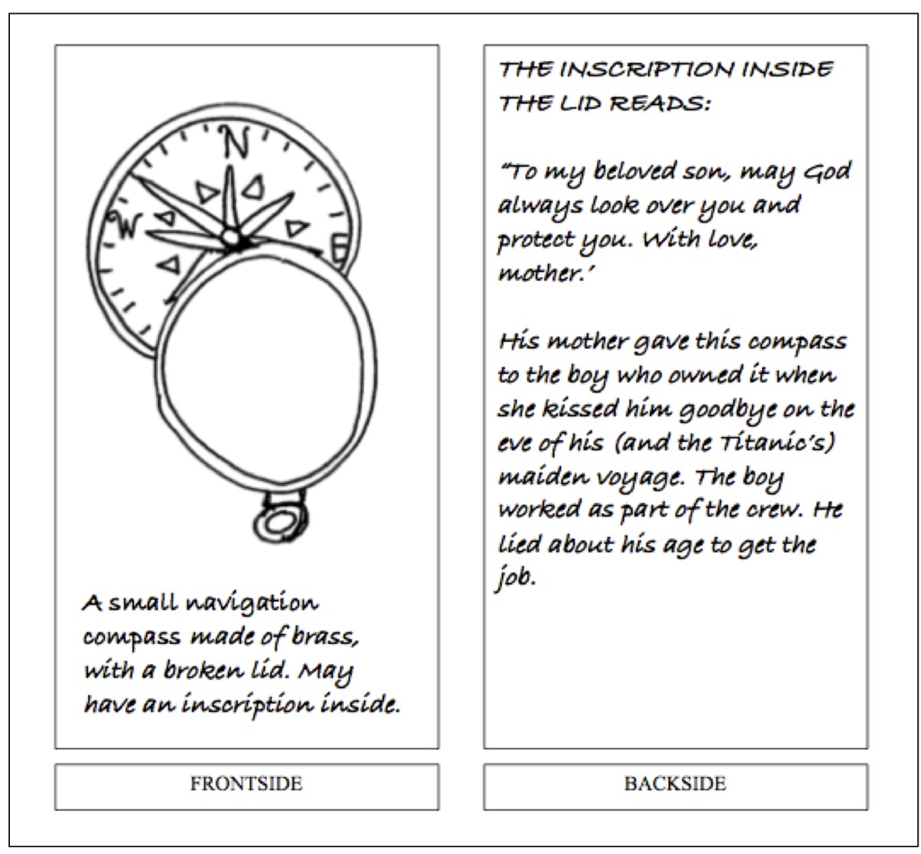

[Note: Depending on the age and confidence of the students some may need help inventing the stories. They don’t need to be completely finished or perfect. Just an idea will be enough. They can be worked on and developed later.]

Step 6. Creating the Wreck
Strategies: 5 - Creating images and other resource with the students.
Key planning aspects: 1 - What’s happening (location, people, events); 4 - Inquiry questions.
The students create the wreck of the Titanic on the seabed using sheets of sugar paper and other resources. They can use books, photographs and websites as research media. The teacher will need to decide on the amount of support they need. This is a ‘representation’ of the wreck, not a reproduction.
Resources:
- Large sheets of sugar paper (or similar); scissors, pens, sellotape, etc
- Topic books on the Titanic.
- Access to the Internet, if possible.

[i] Prepare the resources so they are available to the students. You’ll need quite a lot of space and time for this activity.

[ii] Ask the students to sit in a large rectangle.

[iii] “What have people discovered about the wreck during their studies?”

“I don’t know everything… but I do know the ship spilt in two before it sank and when it landed on the seabed the two halves where more than two miles apart. Now, obviously this space is much less than two miles, so we’ll have to build our model to scale. I know, from the photographs of the wreck, that it is not completely rotten away, but the sea has caused a lot of damage.”

“I’ve collected these materials and thought we could work together to create a model. I’m not sure how it will work; I guess we’ll find that out as we go along. We can use these books and photographs to help us.”

“How should we start?”

Step 7. Putting the artefacts onto the wreck
Strategies: 5 - Creating images and other resource with the students.
Key planning aspects: 1 - What’s happening (location, people, events); 2 - ‘Signs’ for the students to interpret.
In this step the students add the ‘photographs’ of the artefacts they made in Step 5 to the model of the wreck.
As they do so they describe the artefact and where it was found by the archaeology team.

[i] Clear away the resources, ask the students to sit around the model.

[ii] Hand out the photographs of the artefacts.

[iii] At this point in the story the artefacts you have with you are still part of the wreck site… so we need to add them to the model.

We’ll go one at a time. Beginning with those objects owned by the crew.

Who would like to start?

Please place your object on the part of the ship where you found it during the dive…

…As you do so, could you explain what the object is, using your notes. Please don’t include the hidden history.

[iv] The students take it in turns to place their artefact onto the wreck and to describe what it is.

[Encourage the students to work out the order for themselves, give them support if needed.]

[Ask them questions about the objects and take a break if necessary, this activity can last quite a long time.]

Step 9. Stepping into the past
Strategies: 7 – Students in role representing a point-of-view in the fiction.
Key planning aspects: 1 - What’s happening (location, people, events); 2 - ‘Signs’ for the students to interpret; 3 - Something to attract their interest (tension); 4 - Inquiry questions; 5 – Tasks to bring the students into the fiction; 6 – Establishing the Expert Team; 7 – Establishing the Client and the Commission.
In this step the students use the conventions of drama (see Appendix #) to create the stories behind the artefacts and investigate the lives of the passengers and crew.

[i] Ask the students to work in groups and discuss the artefacts they created in Step 5 and added to the model of the wreck in Step 7. Tell them to share with each other the ‘hidden’ stories unknown to the archaeology team.

[ii] Ask each group to choose a story from one of the artefacts they would like to explore together in more detail.

[iii] Ask them to create a moment in the history of that object onboard the Titanic, like a scene from a film. Give them time to discuss and practice their scene.

[Depending on the age of the students and their previous experience of using drama, they may need help and support.]

[iv] Visit each group in turn as they prepare.

[v] Focus on one of the groups – Could I ask everyone to stop and gather round here please.

[vi] Ask the group being observed to stand still in the scene they’ve created as if the film they are in has just been paused. The rest of the class look on.

[vii] Talk to those watching: What do you notice? Don’t worry about trying to guess what’s happening; just say what you see.

- During the discussion ask the people in the fiction not to move or talk – “Let those looking do the work.”

- If after a while those watching need more information then talk to the people in the fiction to find out more – “We’d like to ask the people in the story…”

- As you and the class ask questions remind those in the fiction to stay in the scene and only to answer the questions asked.

[viii] When ready, ask the people in the fiction to show the next five seconds of the film.

[ix] Once they've finished ask them to hold still once more and work with the rest of the class to make meaning from what they have just seen. Use the rubric – Action, Motivation, Investment, Models, Values – as described below.

[x] Repeat with the other groups.

[These scenes can be used later in the final exhibition.]

