Bear Sanctuary
Title: Bruno’s Bear Sanctuary
A bear sanctuary with a history of caring for sick and abused bears before returning them to the wild is asked to help a bear that has been illegally maltreated as a dancing bear.

Context:
An experienced team has been looking after European Brown Bears in a mountain environment in Europe for many years. The sanctuary was founded by a lady named Roxanne after her pop career faded (see Michael Morpurgo’s The Dancing Bear) and has since rehabilitated many injured and abused bears before returning them to the wild. The team prides itself on maintaining as natural an environment as possible within the sanctuary, monitoring closely the levels of human intervention.
The team is commissioned by the Serbian police to accompany them to a Roma community in rural Serbia. The police have evidence that a bear is being kept in captivity as a dancing bear. Many pressures, including poverty, war, lack of opportunity and a desire to maintain dying traditions, have led the community to keep the bear dancing, despite the practice being illegal. The Bear Sanctuary team is asked by the police to take full responsibility for the welfare of the bear.

Main Curriculum areas:
Sc2 Life processes
Sc2 Variation and classification
Sc2 Living things in their environment
Adaptation
Feeding relationships
Sc2 Humans and other animals
Nutrition
Circulation
Movement
Ma – measurement, weight, volume
Ma 4 Processing, representing and interpreting data
Geography - Knowledge and understanding of places
Study a range of places and environments in different parts of the world, including the European Union – the mountain environment

Overview:
Author: Julia Walshaw
Theme: Animal welfare and protection
Age Range: Bear Sanctuary frame applicable to EYFS to KS2, but this particular client and commission suitable for upper KS2
Main Curriculum Focus: Science: SC2: Humans & other animals
Inquiry Question: ‘What are our responsibilities towards other living things?’
Expert Team: Those who run a bear sanctuary
Client(s): The police in Serbia
Commission: To rescue and rehabilitate a bear that has been used within a Roma community as a dancing bear.

Inquiry Questions:

Social: How can we work together with different communities? Should all communities share the same values?

Cultural: Should longstanding cultural traditions be maintained at any cost?

Political: What responsibilities do we (society) have to help animals in trouble? Should our values be imposed on communities with different needs and experiences to our own?

Historical: Are the values and practices of the past relevant and acceptable in a modern context?

Environmental: How can the mountain environment be managed sustainably and why is this
important now and in the future?

Critical:

Ethical: What are our responsibilities to protecting animals?

Philosophical:

Spiritual: Do animals have feelings? Do animals have souls?

Steps in:

- Task - this is a long ‘entry’ into Mantle of the Expert as it starts with the reading of a book
Use The Dancing Bear by Michael Morpurgo as a class book, in whichever way suits the circumstances of your class and allowing plenty of time for discussion as you go along. The book is fairly short.

- Moving into creating your own context
Inquiry question – ‘I wonder what might have happened to Roxanne after the end of the book?’
Give the children opportunity to answer and discuss. Ask some follow up questions, in a conversational way, it’s important not to interrogate them…
Guide the children into thinking about how she might have felt about the death of Bruno the Bear in the months/years after she left the village.

- Negotiating adult in role
Roxanne will be represented by an adult in role. Use of role will provide many opportunities for exploring different points of view in the work. If you don’t have another adult available
then you could represent the role yourself, although it would be a bit more difficult.
‘Perhaps we could see what has happened to Roxanne? Could we ask Mrs. X if she wouldn’t mind representing Roxanne?’
The adult comes round and stands behind a chair ready to sit down. It is important to go
quite slowly at this point, particularly if the children are not familiar with adults in role.
“When Mrs. X sits down she is going to speak as Roxanne. She will be able to hear you and talk to you, but perhaps to start with we should listen to her story…’
‘Mrs. X could you please sit on the chair and we’ll hear a little of Roxanne’s story.’

- Adult in role - establishing Roxanne as the founder.
(The notion of Roxanne as founder will provide a rich context to the Bear Sanctuary, providing opportunities for further exploration of the text and its characters. The fiction of the sanctuary created by the children will weave in and out of the fiction of Morpurgo’s story.)
Mrs. X speaks as Roxanne. She can interact with the children, but should not get too diverted at this stage from telling her story.
Where possible Mrs. X should incorporate some of the children’s ideas from STEP 2 into Roxanne’s story. This will give the children a sense of ownership and feel that their contributions have been valued.
In order to build the context of the bear sanctuary, the basis to her story should be that:
- her pop career faded out
- she felt guilty about Bruno dying
- she decided to return to her village, using the money she had earn in her pop career to set up a sanctuary to help bears (perhaps to assuage her guilt?)
Teacher - ‘Perhaps we’ll leave Roxanne for now. We can always talk to her further if we need to.’
Mrs. X gets up from chair. Thank her.

Steps in continued:

5. Talking with the children… the ‘problem-free’ question...
Question: “I wonder, if you had a job in this place that Roxanne set up…… what kind of
job would you think it important to do?”
Give the children chance to answer. Ask some follow up questions, again in a conversational rather than demanding tone.
“Ah, feeding the bears. Any kind of food in particular? Does anybody help you prepare the food?”
‘I see, you need to give the bear some stitches. I wonder where we keep the equipment for that?’

It’s important here to start talking ‘inside’ the fiction. Notice the switch to ‘we’ as you start to build
the team first through the language of collaboration.

6. Shifting into the enactive to enable all children to participate
Task: The children will now hopefully be contributing lots of ideas about the jobs.
‘It sounds like there are lots of jobs in this place. I wonder if for a moment we could just see the team at work. Just for a moment, could you show us one of the workers hard at work. If your job needs more than one person, you could always show us your job along with a friend’

Respond encouragingly to those who take this step into the enactive. This will help others…
‘I notice you are preparing an injection. It looks like a lot of care is going into that’
‘I see you two are getting some food ready. I can see why it takes two of you – looks like hard work!’

7. Creating the bears… (Resources: strips of A4 paper)
Task: “Um, it looks as if we have quite a few bears here… I think it might help if found out just how many we’re dealing with. Could you please grab a strip of paper from the pile here and write the name of the bear it is your job to look after in the sanctuary. I know that some of the bears are too much work for one person, so you may want to team up.’
‘If you get a chance, perhaps you could write on the back of your paper the bear’s age, and how long you have been looking after it…’
(Here we are starting to build a sense of the team’s history and previous successes).

It’s important here to maintain your language from ‘inside’ the fiction. Slowly but surely, this will build a sense of ownership and belonging for the children.

Steps in continued:

8. Scaffolding their work…(resources post-its)
Tasks: As the students discuss and write, go round the room looking at their work, ask them a question or two about it. Then as they work:
- “Sorry team, I know you’re busy… but could you just look this way for a moment? Thanks. If you get a chance, could you get yourself one of these post-its. If there’s a piece of equipment you need for this bear, perhaps you could draw it on a post-it and stick it on your strip of paper. That’ll help us all be clear about which bear needs what’.
- ‘It looks like these bears eat quite a mixture of food. If you get a moment, perhaps you could show us the food or foods your bear eats on one of the post its.

  - Notice, once again, how the slight shifts in language develop the idea that we are a team. The gradual extensions to the tasks are developing the context and creating the team’s responsibilities.
  - Drawing the equipment will move the children into ICONIC representation – the idea that meaning can be represented through drawing.
  - This process will also give you a chance to assess what the children already know, for example about a bear’s diet. Don’t worry too much for now about any misconceptions – these can be addressed later in the work. The important thing now is to build meaningful CONTEXT and OWNERSHIP – something for the children to start to care about.

9. Creating a map (resources – large sheet of paper, or perhaps several stuck together with sellotape)
Gather the children round a large sheet of paper. They should have their bear name strips with them.
‘It seems that there are some bears who need a lot of care, and others who can pretty much look after themselves. I was just wondering if this makes any difference to where they live in the sanctuary?’
Enable the children to discuss the organization of the sanctuary, making meaning by placing the bear names down on the paper to show where that bear lives.
Children may start to discuss fences, trees, buildings etc. Enable them to start to draw these onto the paper. ‘Ah, I hear you’re talking about a fence. Could you just indicate where this fence is on our plan of the sanctuary?’

The main elements of the sanctuary are now established – bears, equipment, layout. This will form the context for many tasks to come…

10. Introducing the client

Tell the children that we (the sanctuary team) have received a request from the Head of Police in Serbia for a Skype call at a specific time.
Negotiate with the children how we could represent the creation of a Skype call in our story – perhaps through ICONIC representation by drawing the ‘call’ and ‘end call’ icons on a piece of paper.
You’ll need an adult in role, which could be yourself if you have no-one to call on.
The adult in role should sit on a chair, and when the class are ready, someone should touch the ‘call’ icon to represent the start of the Skype call.

The adult in role should explain the problem of the dancing bear (see context on page 1). At this stage ‘less is more’; the children will have the chance to find out more about the bear and the Roma community at a later stage. For now they need to know the essential elements of the problem, infused with an element of tension and secrecy.

The adult in role (through the convention of the Skype call) can be paused, stopped or rewound if necessary, to give the children the opportunity to hear something again.

From this point on, the bear sanctuary team have a new client and a new commission, which will provide the children with many challenges and tasks.
Planning for the journey to Serbia will be necessary, as well arrangements for safe and humane treatment of the bear.

The encounter with the travelling community (using adults and possibly children in role) will need to be dealt with sensitively. The team’s investigation should reveal the deeper motives and points of view behind the community’s treatment of the bear – for example the pressures of poverty, war, lack of opportunity and a desire to maintain dying traditions. This will challenge the children’s thinking, and possibly preconceptions, in a way that goes beyond a simple problem with a bear.

POSSIBLE FURTHER TASKS AND ACTIVITIES:

Possible further tasks and activities:

The team - identity and values  Logo  Name  Website  The clothing worn by the team while working | The team - safety of individuals  Equipment worn to protect team from bears  Procedures for safe handling of bears  Protocol for when handling/intervention is necessary | The team - history of the sanctuary  Bears helped in the past by the sanctuary – their stories  Interactions with the founder Roxanne
The sanctuary – buildings  Indicate buildings on sanctuary map  Portals and barriers  Design layout and contents of each building, according to purpose  Scale models and drawings of each building  Security and lighting for buildings – electrical circuits  For sick and recovering bears, consider safe and humane containment (shape and area) | The sanctuary – layout  Different zones for different levels of care, shown on large map of sanctuary  Records of needs of bears in different zones, using eg Carroll and Venn diagrams  Geographical features of the habitat eg of mountains, rivers  Fencing (perimeter)  Four quadrant co-ordinates to designate hibernation locations  Organise and maintain surveillance and management of all areas | The sanctuary – security  CCTV cameras – location and monitoring procedures and rotas  Security fences – height, perimeter  Implications and motives of any intruders  Procedures for breaches of security
The bears – hibernation  Location of hibernation sites  Remote monitoring of hibernation  Factors to monitor including heart beat, breathing rate, body temperature (compare to normal rates in mammals)  Jobs done by the team whilst bears hibernating  Possibility of new cubs born during hibernation  Possibility of non-hibernating bears – why? | The bears – treatment  Treatment procedures for physical problems (to include consideration of teeth, skeleton, muscles)  Treatment procedures for psychological problems caused by mistreatment  Protocol for when medical intervention is necessary | The bears – feeding  Measurements of food/milk given to bears, using different scales  Food chains  Food webs  Implications to bears of a problem lower down the food chain  Suitable foods for different species of bears

Resources:

Books:

The Dancing Bear by Michael Morpurgo
ISBN 978-0-00-674511-2

Bears A Year in the Life by Matthias Breiter
ISBN 978-0-7136-8712-5

100 Things You Should Know About Bears by Miles Kelly
ISBN 978-1-84810-101-2

Websites:

http://www.bbc.co.uk/nature/life/Bear
Reliable fact files on bears.

http://www.bear.org/website/
A bear sanctuary in Minnesota, USA that has featured in BBC documentaries. The website features an excellent webcam of a hibernation den.

http://www.wspa.org.uk/wspaswork/bears/sanctuaries/

http://bearsanctuary.com/libearty-bear-sanctuary

DVDs:

Natural World – The Bear Man of Kamchatka
BBC Worldwide

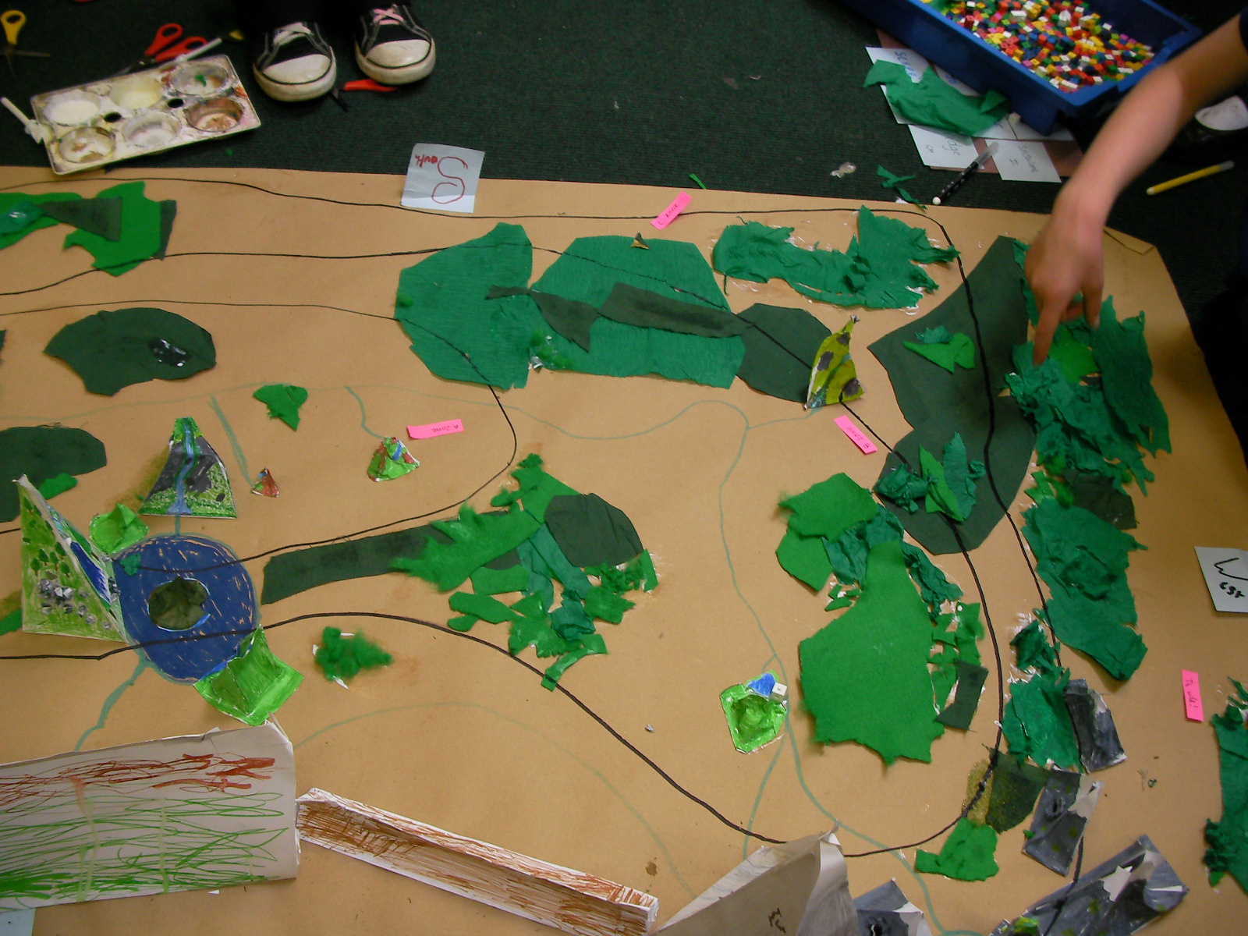

Creation of map of the sanctuary, showing different zones, features of the mountain environment and plans of the interiors of the builidings

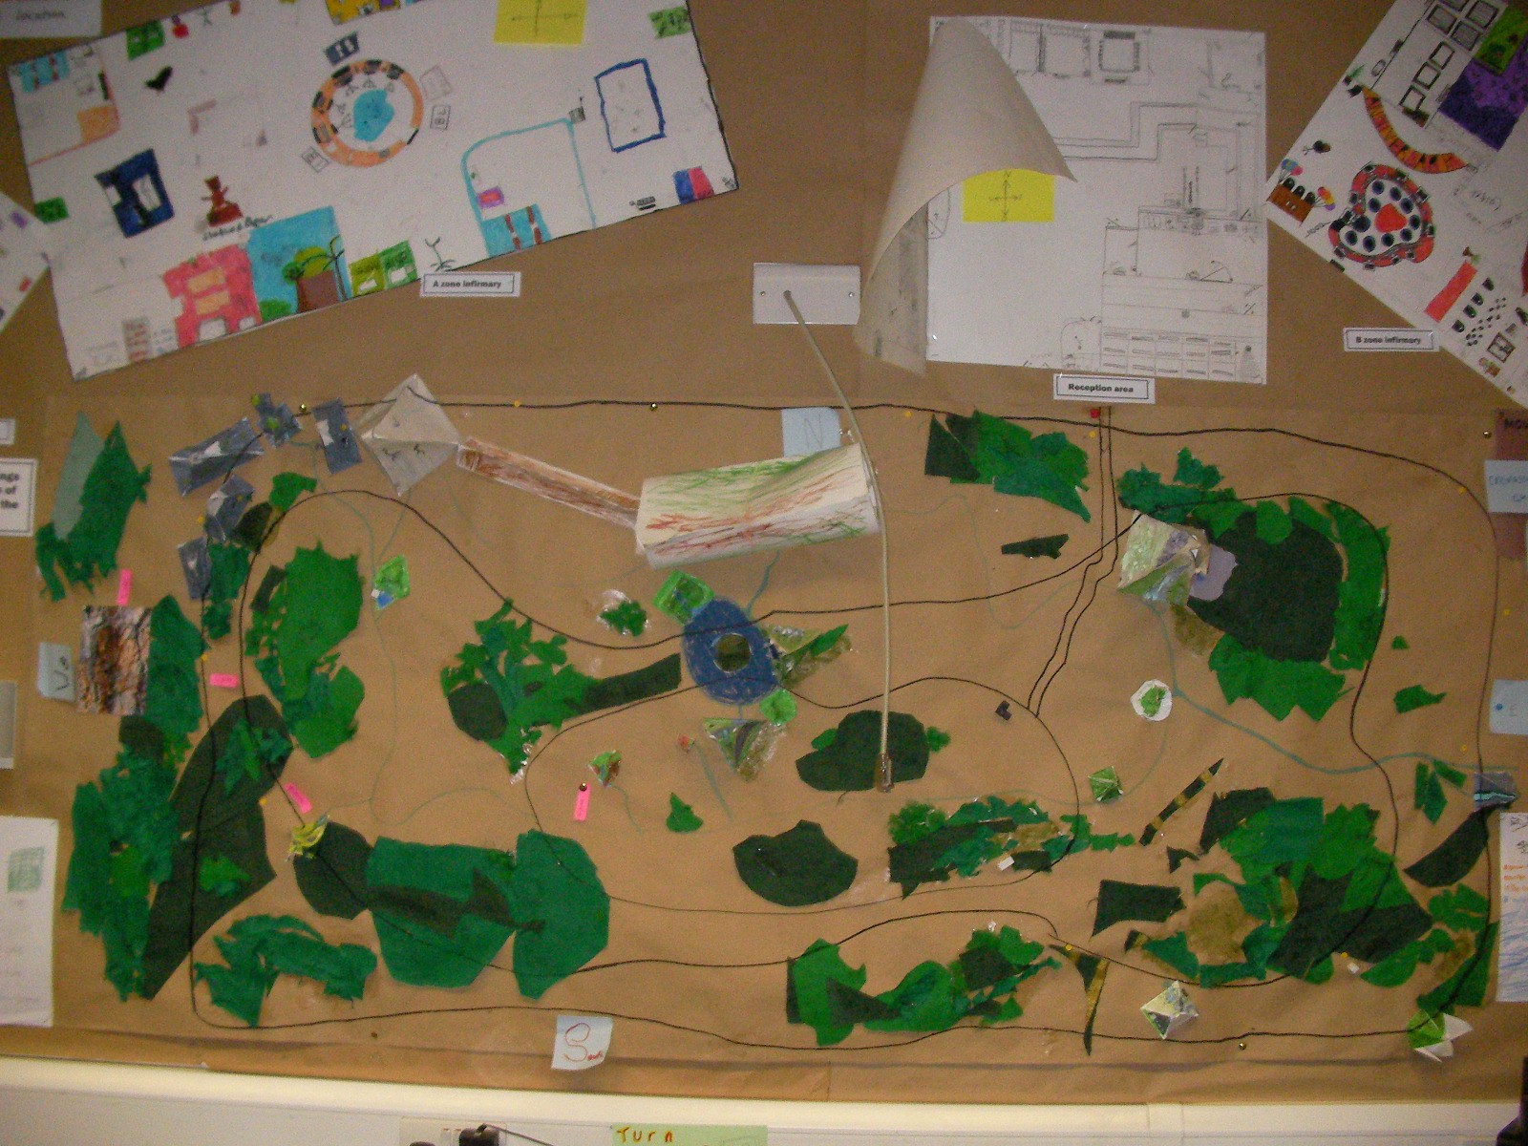

Pupils from Y5 and 6 discussing Mantle of the Expert and Bruno’s Bear Sanctuary

‘You feel involved. You want to do it more because you feel like you’re helping; you’re part of the problem.’
‘With writing, I love the fact that you’re creating it, but at the same time it does something for the Mantle. You’ve done your part. ’
‘It inspires creativity. It’s satisfaction.’
‘We’re not told what our bear has done. We create what our bear has done.’
‘You can contribute to it. It’s your problem. You feel more part of it. You feel more intent on working on it. It’s a lot like everyday life really. They’re problems that could happen. It prepares you for real life. You know you to deal with problems, how to react, not to panic.’
‘It’s preparing us, like when we had the recession at the Sanctuary. That’s something that’s actually happening to people. They’re grown up problems. I like working around things that are actually happening like in real life. You hear about it on the news, like the credit crunch. When you get to school you’re actually doing it, solving problems about it! It makes you feel more important.’
‘We brought it to life. We make things come to life and it’s much more fun than just seeing it written down on a piece of paper.’
‘You get feedback from everyone else.’
‘Drama is the whole base of it. I love it when we talk to someone about stuff in role as someone. I like how we can come into the role.’
‘You get different aspects, different views, different opinions. In different positions you can find out different things. You get their background.’
‘When we get in role it’s like in life. You can ask the questions. It encourages a lot of team work.’
‘We always find a way somehow. We don’t just have one answer.’
‘You’re part of the sanctuary. We’re not watching it from a distance. We ARE Bruno’s Bear Sanctuary. You’re part of it. We are it.’
‘The dancing bear was a difficult one. That was really challenging - I liked it! In life everything won’t be easy. It will be slightly harder than you expected. At first glance it was just a cruel man with a dancing bear. But then we went deeper into his family and heard his views. Then we had a problem!’
‘It was black and white. But then you discover more. You go into colour.’
‘It’s harder because then you don’t know what to do, but that’s what happens in life, you find more problems.’
‘Life’s not black and white. You look deeper into it then it becomes colour.’

