|  |  |  |
| --- | --- | --- |
| **Details** | | |
| Title | Kindertransport | |
| Overview | Author | E Bramley |
| Theme | World War Two |
| Curriculum Focus | History, Literacy |
| Age Range | Year 5/6 |
| Context | Scenario | In the lead up to World War Two Nicolas Winton was personally responsible for organising the transportation of 669 Jewish children to be transported from Czechoslovakia to Britain and other countries. He organized their train passage as well as foster care families to look after them however the last train he organized never left Prague as war was declared. Nicholas (Nicky) kept all of this a secret and it wasn’t until his wife found an old suitcase containing information about the children that his act was discovered and his achievements were recognised. ‘Kindertransport’ is the name that was collectively given to these children.  The Information Center (part of the Memorial to the Murdered Jews of Europe) in Berlin has recognised that their exhibition doesn’t cater for children. They want to create a story book that tells the story of the Jewish refugee children that were taken to England, from Prague, by Nicholas Winton. They ask a group of children’s authors and illustrators to create a series of books that will appeal to children but also inform them of the story of Kindertransport. |
| Expert Team | Children’s Authors and Publishers |
| Client(s) | The Information Centre |
| Commission(s) | To create a children’s book which will tell the story of the evacuation of children from Prague to Britain in the lead up to World War Two. |

|  |  |  |
| --- | --- | --- |
| **Planning imaginative-inquiry** | | |
| **Area of Study:** | | |
| **PLANNING THE INQUIRY**  (Ref: *Inquiry Questions Grid) | | |
| Planned learning outcomes | Knowledge | * The names of the different countries involved in WW2 * Where the different countries are in relation to one another * How Prague was involved in WW2 * Why the Jewish community was persecuted * Who the Nazi party was * Who Hitler was * How the war started * How the war was reported * Why the war started * How the war finished * How war was declared * How the war affected different communities * What happened to Jewish families * What the Holocaust is * The key dates * Different modes of transport available in WW2 * Forms of communication in WW2 * How information was passed on * Different forms of personal identification * What an evacuee is * What happened to some evacuees * The role of foster families * The food, clothing, lifestyle in the UK during WW2 * Rations * What a memorial is * The role of memorials |
| Skills | Map reading  Logistics   * How to present facts as stories * How to research using ICT * How to tell a story from different points of views * How to use descriptive language * How to draft work * How to redraft work * How to give constructive feedback * How to plan creative writing tasks * Analyzing historical information |
| Understanding | What makes people help others  Why Nicholas may have kept his work a secret  How it feels to be evacuated  The different choices and decisions people make in times of war  What life may be like for people that move countries |
| Aspects of the area of study likely to interest & engage | The children and families feelings and thoughts at being evacuated to another country and how it may feel to leave your home to live somewhere else.  The decision that Nicholas Winton made to help children and families that he didn’t know.  The persecution of a community and the effect of war on children.  The logistical demands of relocating children with new families and the responsibility of those involved.  The difference in different countries and ways of life that would have impacted on the children.  The challenge of representing a factual event in the form of a children’s book.  The different stories and points of view involved in Kindertransport. | |
| Inquiry Questions | Why did Nicholas keep it a secret? Should he have helped? Should we help even if it puts our lives in danger? Are people either “good” or “bad”? What makes someone ‘good’ or ‘bad’? Can people change? What is a ‘hero”? Can ordinary people be ‘heroic”? Can one person make a difference? What is war? Is war ever ‘right’? When is ‘war’ ok? What is ‘peace’? What is our responsibility to those in danger in other countries? How do we prioritize who to help? Should we help? What different things can we do? How can we help people who arrive in our country from other countries feel safe? What support do people need? What is ‘danger’? What makes people feel safe? What do we need to feel safe? What makes you feel safe? Does everyone have the right to feel safe? What happens to children to leave their home land because of war? What challenges will children face in a new country? What will be different for them? What will they bring with them? | |
| Lines of investigation | **Transport**  • What different forms of transport are there? What forms where used in WW2? How has transport changed? How have train journeys changed?  • What is a train journey like? What happens on a train? Who works on a train? What do they do? What equipment do they need to do their job? Where have you been on a train? How fast can the fastest train go? Where is the fastest rail link? What is it like to ride on a fast train? How does a train go so fast?  • What different options did Nicholas have? Why did he choose trains? What would you have chosen? Was this the safest way to transport the children? What would they need to organise for this train journey to happen? How would they get through the boarders? Did the children have tickets? How do you make sure no ones luggage is lost? How did the children eat/sleep etc on the train? What resources would they have needed?  • How many children could a train take? How long would the journey have taken? What route did it take? When would the children have been ‘safe’?   * What would the train look like? What fuel did it use? Has this changed? Where would they stock up on their fuel? What different types of fuel are there? Where do we get them from? What are the good/bad things about using the different types of fuel? What fuel was available at that time? * How would they organise the seating? Would you put younger children with older children? Where would they have slept? How long would it have taken? Which different countries would they have gone through? What happens when you go through a boarder? * How would it have felt to leave the platform? How would it have felt to arrive in England? What would you have packed? What precious items would you have sewn in to your clothes? How would you remember your home? * What would you say at the platform if you were a child/parent? If you put a letter in your child’s suitcase what would you write? What would you write in your diary the first day? The middle of the journey? The end of the journey?   What games would they have played on the train? What songs would they have sung on the train? How would they entertain themselves? How is this different today?  **War**  • Why did the war start? Who was the war between? When did it happen? How did it end?  • What is an evacuee? Why did the Jewish children have to leave? How did the Nazi’s know someone was Jewish? What happened to their  parents?  • What happened to the children on the last train? How would they have felt? How would Nicholas have felt? How would you have felt?  • Do we behave differently in a war? What is war? Why do people go to war? Is war always ‘bad’? What wars are happening at the moment? What is life like for those children living with war? Are there still child evacuees?  • How do we know if we are at war? What happens to the children in war? What changes for them? What is life like for them?  • How can children be protected in war? How can parents keep their children safe in war? Should they send them away? What risks are there?  • Was it only ‘Kindertransport’ that were evacuated?   * What happened to the children after the war?   Did it only involve the children Nicholas saved? | |

|  |  |
| --- | --- |
| **PLANNING THE EXPERT FRAME**  (Ref. *Expert Team Grid *Generic Clients Grid *Generic Commissions Grid) | |
| The scenario | A team of children’s authors have a successful history of creating engaging and imaginative books for children based on different periods in history. They have an excellent reputation and sell their books world wide in many different languages. They have been contacted by the Jewish Memorial Museum who have recognised that their museum lacks a focus on engaging children in the story of the Jewish community during World War Two. They have decided that a series of short fictional stories based on Kinderstransport would benefit the museum however they also feel that the role of Nicholas Winton and his actions during World War Two should be celebrated. They contact the team as they feel they have the skills, attitude and quality of work that would be ideal to create the books. |
| The Expert Team | The team not only write books but also illustrate and publish them. They specialise in creating fictional stories based on historical events. |
| Client(s) | The Information Centre sits underneath the Memorial to the Murdered Jews of Europe in Berlin. The Information Centre holds a permanent exhibition that tells the story of the persecution of the Jewish community, the evacuation and the transportation to camps from across Europe. They are keen that the stories of the children who were part of Kindertransport are shared but also that the work of Nicholas Winton is recognised. The centre has had excellent reviews and is a popular tourist destination however would like to be able to offer children who come something suitable and informative. They feel it is very important that the books are factually correct in terms of the details such as the journey route however would like the team to create and imagine the thoughts and feelings of those involved. They are not concerned with which part of the story they want to tell however would like to the team to create something that will both engage and inform children. |
| Other roles adding depth & challenge to the context | Nicholas Winton  Grete Winton  BBC News  The children  The families  The foster families  The local community  The schools  The authorities- this may involve the different governments involved in making decisions  The train driver and crew |
| The commission(s) | The Jewish Memorial Information Center is based in Berlin, Germany. We exist to remind people all of the Jewish children and adults that were killed in World War Two. We have a large memorial as well as an exhibition and information center. This is where people can find out about the history of World War Two and what happened to the Jewish people during this time.  We are concerned that not enough children are visiting the information center and we have received feedback from children that the exhibition is does not appeal to their age group. We would like to make sure that everyone, young and old, are able to find out about what happened to the Jewish people but in particular some of the children during World War Two.  We are particularly interested in the story of the Kindertransport and of Nicholas Winton and would like to create series of books for children about his story. Kindertransport is the name given to a large group of children that were evacuated from Czechoslovakia just before the war began. Nicholas Winton was key to these children being safely transported and we would like to make sure that everyone hears his story.  We have heard about your wonderful work on ... and are hoping that you can help us with a very important project. We hope you can help us create something interesting for children so that they understand why these children had to leave their homes and families, how they left and what happened to them afterwards. |

|  |  |  |
| --- | --- | --- |
| **PLANNING** **ACTIVITIES &** **CURRICULUM LINKS**  (Ref. *Generic Activities Grid) | | |
|  | **ACTIVITIES** | **CURRICULUM LINKS** |
| Activities for the commission | * Newspaper articles from different points in the story * Radio reports on the war * Diary entries * Timeline of key events * Presentation on element of WW2 * Interviewing Nicholas (teacher in role) * Creating the scrapbook found in the attic * Researching WW2/Kindertransport * Interviews with children now as adults * List of names * Identification * Organisation of luggage * Rations list * Equipment lists * List of adults and their responsibilities * Seating plans * Mapping the route * Calculating the route * Organising crossing boarder security * Getting official permission from governments involved   Timeline | History:  6. A study of an aspect or theme in British history extends chronological knowledge beyond 1066  For example: - the changing power of monarchs using case studies such as John, Anne and Victoria- changes in an aspect of social history, such as crime and punishment from the Anglo-Saxons to the present or leisure and entertainment in the 20th Century- the legacy of Greek or Roman culture (art, architecture or literature) on later periods in British history, including the present day- a significant turning point in British history, e.g. the first railways or the Battle of Britain |
| Activities for the Expert Team | Name of team   * History * Best sellers * Operations * Departments and responsibilities   Sales   * Planning the story with a timeline * Writing story * Checking draft against the commission * Redrafting work * Illustrating | Composition   * plan their writing by:  1. discussing writing similar to that which they are planning to write in order to understand and learn from its structure, vocabulary and grammar 2. discussing and recording ideas  * draft and write by:  1. composing and rehearsing sentences orally (including dialogue), progressively building a varied and rich vocabulary and an increasing range of sentence structures (See Appendix 2) 2. organising paragraphs around a theme 3. in narratives, creating settings, characters and plot# 4. in non-narrative material, using simple organisational devices such as headings and sub-headings  * evaluate and edit by:  1. assessing the effectiveness of their own and others’ writing and suggesting improvements 2. proposing changes to grammar and vocabulary to improve consistency, e.g. the accurate use of pronouns in sentences  * proof-read for spelling and punctuation errors * read aloud their own writing, to a group or the whole class, using appropriate intonation and controlling the tone and volume so that the meaning is clear. |
| Activities for developing the context | * Diary entries * Letters home * Debate on sending child away or not * Pros and cons list * Telling your child /receiving the news * Packing the suitcase * Sewing precious items in to the clothes * Advertising for foster families * List of attributes for foster families * Recounts as to why people would foster   Leaflet welcoming children to UK (food, celebrations etc) | Literacy:  a. in speaking and listening children should:  1. develop and apply speaking and listening skills to suit a variety of audiences and for different purposes  2. tell and listen to stories and explore ideas and opinions in both formal and informal contexts  3. express themselves creatively in improvisation, role play and other drama activities  4. use digital and visual media to support communication both face-to-face and remotely.  c. In writing children should:  1. learn to write for a variety of purposes, for a range of audiences and in a range of forms  2. develop their understanding of how writing is essential to thinking and learning and is enjoyable, creative and rewarding  3. explore writing using different media including web pages and multimodal formats in English and in other languages. |

|  |  |
| --- | --- |
| **Developing the Context**  (Ref. *) | |
| Other points of view | The initial phone calls between Nicholas and his friend who told him about the children.  His wife’s discovery of the suitcase in the attic  Nicholas choice to keep what he did a secret  The children as adults  The foster families choices and decisions  The people who helped organise the foster families  The different children’s attitudes, feelings and experiences |
| **Planning the Start**  (Ref. *) | |
| Planning the first sequence of steps into the imaginative-inquiry | 1. **Introducing the Story**   When we think about World War Two what images comes in to our minds? Can we think about the people that would be involved? How might we show those in marble, like a statue? Which of our statues would we say shows someone who is brave? (discuss their ideas and choices) We agree that this is what brave people look like? Perhaps you can tell me what makes someone brave? We’re going to explore a story of someone that we might consider as brave. It begins with a suitcase. One man and a suitcase hidden away. Years later the suitcase lays in a dusty attic, not quite forgotten.  (Enact Grete Winston cleaning out the attic, finding a dusty old suitcase hidden in the corner and slowly opening it. Inside it is effective to have copies of the pages Nicholas Winton’s scrapbook inside it. Slowly, with a sense of ritual open the suitcase and spread the pictures, id cards and letters across the floor. Allow the children to explore, discover and raise questions.)  It may be useful at this point to go back in time. To see Grete’s husband Nicholas/Nicky when he was a young man.  I’m going to show you a short film of Nicky at his office and it takes place in 1938 which is quite a long time ago. In fact it is just before the start of World War Two. We are going to be able to hear what he is saying at this moment in his office in 1938. Can we agree that when I/TA begins talking that they are no longer me/TA but are Nicholas Winton? You’ll be able to see him and hear him.  (The ‘film’ begins to ‘play’. Nicholas speaks in to the telephone and a sense of urgency and desperation is important). Yes, I can help. In fact we have to help. But how can we get them all safely to Britain? They will need a £50 each. And then there is the food, the transport and where will they live when they get here? I will think of something but we have to save as many children as we can.” (Hangs up phone. PAUSE the action.) “So that is part of the story. Perhaps we could hear a bit more. Do you think that would help?  (PLAY the film again adding) But there is so much to think about. How can I move so many children safely to another country? (PAUSE.)  Would it help if we had the chance to speak to him? There are part of the story we now know. We will need to find out as much as we can however we wont have long because as you saw he is very busy.  (Bring Nicholas to life and let the children speak to ‘him’. He will need to give key information such as:   * they are in danger from the Nazi’s * it is 1938 and war is starting * if the children don’t leave Prague their lives could be in danger * the parents cannot go as well * he needs to find foster families to look after the children * time is precious because of the impending war situation   (Discuss the information explored so far.)  **2) Opening up the Inquiry**  You may want to make an investigation wall where the children add to of what the children think is important or even a timeline so that every time a key date is discussed it is added to the timeline. Questions could also be added to the timeline by the pupils as points to further explore. One class used a train line as the time line and carriages as key points along the way with signs for countries etc mapping the journey and details of the investigation as it progresses. This created visual gaps of understanding and identify areas for further inquiry.)  Imagine planning and organizing the evacuation all of those children safely from one country to another. There must have been a lot to think about? Did anyone notice the book on Nicholas’ table? Can we imagine that inside is a list of everything he would need to think about in order to move the children safely? I know that life was very hard at those times.  (The children, as themselves, sit in a circle. Slowly place a suitcase, old and battered if possible, in the middle. Explain that suitcases are very important in the story.)  Nicholas told us that the children had to leave Prague because there was a war. And I suppose that they don’t know how long they will be away from home? They probably have no idea how long the war is going to last. I’m thinking about this suitcase and I’m wondering “if” it were yours, your suitcase, and you had to pack, to leave your family, because there is a war going on, then I’m wondering what you would pack? Yes probably clothes. Would anyone like to pack something to remind you of home or to make you feel safe? I suppose I am wondering what you would take with you? It would probably be something very special or precious to you. Can you imagine “if” you had to ‘evacuate’ and leave your family what one precious thing would you take? I’m really sorry however you can’t take your pets. Why not? Because we can’t allow them on the train. We have to save the resources for the children. We have to make sure you are safe and we cannot risk having any animals on board*.*  (Ask the children to either share their items with their partner explaining why they are taking that item then come and place their items in to the open suitcase explaining what they have packed and their reason for choosing them.)  **3) Exploring different perspectives**  And now we have packed I suppose it is time to leave. I don’t know what you have been told by your families. You may know that there is a war about to happen. You may know you are being sent away to escape the war and in some cases I know that the families didn’t tell their children the truth. I guess that would be a hard decision for a parent to make? To tell their children that they are sending them away, possibly forever or to lie to them? I’m trying to imagine what I would say if it were me? Do you think this is an important part of the story?  (In pairs ask the children imagine that they are parent/child.  Ask the children to sit back to back with one imagining they are a child and the other that they are the parent. Ask them to imagine what they would say. Give them a chance to each explore a different perspective. Explain that you will walk around the room and as you pass a pair you can overhear their conversation. Note what you have heard in particular any common themes or any different ideas. Discuss with the children the key themes e.g. Who told their child the truth? Who lied to the child? Why did you lie? I think we call those white lies. Is it ever ok to lie? Does it depend on the age of their child? So how old would they need to be to hear the truth? Is there a right or wrong? How might the children have felt later when they found out their parents had lied to them? How would you have felt? The questions should be non judgmental but rather explore that the decision the parents made was difficult.)  **4) Leaving**  And do it is time to leave. It is time to say goodbye. (Standing in a circle ask one child to draw a line, in chalk, on the floor. Explain that this is the railway station and that the train to England is leaving soon.) In a moment I am going to ask you to come and create a photo with your bodies of the platform the day the train was about to leave Prague for England. I don’t know if you are going to be a child waiting to go but of you are don’t forget your suitcase! Perhaps you are going to be one of the parents saying goodbye to your children? Perhaps you work at the station? I don’t know what you are doing or how you will be feeling but I do know that it is the platform and on the day the train is leaving for England. “if” this were you what would you be doing? How would you be feeling? Can you step forward when you are ready?  When I tap you on the shoulder I can bring this photo to life. It will be really interesting to hear what those children and parents are thinking on this important day. I wonder what the children are thinking and I wonder what the parents are thinking. Sometimes we say something different to what we are thinking. Can you write down on the yellow slips what your person is thinking at the moment the photo was taken? Can you write down on the red slips what that person was saying at that moment the photo was taken. I’d be interested to hear what people were saying so as I walk past you your photo will be able to come to life. I’m going to be able to hear what you are saying. Now I’m going to do the same thing again but this time I’m going to be able to hear what you are thinking. I’m wondering what will be different, what will be the same. (Spend some time discussing this or exploring what they offer further within the roles adopted.)  In each of your pockets is a letter. (hand out sheets of paper and envelopes). You haven’t read it yet. It is sealed. But you will once the train has finally left the station. Once the train is on its way to England carrying the children away from their families but to safety and to new families. What might those words be? Who might that letter be from? Is it to you? It may be from a parent to a child, or perhaps from a parent to the new family or even from the child to the parent? In the suitcase in the attic Grete found letters. Some of them were to Nicky from the families. Take out your letter. Imagine those words. We know they are important, we know they are special. (Give some writing time. You may decide to share these or seal them and use later.) |
| **Resources, Links and Other Material**  (Ref. *) | |
|  | <http://www.stiftung-denkmal.de/en/memorials/the-memorial-to-the-murdered-jews-of-europe.html>  <http://news.bbc.co.uk/1/hi/4531669.stm>  <http://www.bbc.co.uk/news/world-europe-12237594>  <http://news.bbc.co.uk/1/hi/uk/8227798.stm>  <http://www.just-powell.co.uk/winton/>  <http://www.youtube.com/watch?v=6_nFuJAF5F0>  http://www.telegraph.co.uk/history/10064216/The-unsung-British-hero-with-his-own-Schindlers-List.html  Copies of Nicholas Winton’s scrap book can be found here:  <http://www.hereford-starlab.co.uk/NGW/WintonsList/images/SCRAP03_REPORTA_19391002.gif>  <http://www.hereford-starlab.co.uk/NGW/WintonsList/images/SCRAP08_FRANK_LETTER.gif>  <http://www.hereford-starlab.co.uk/NGW/WintonsList/images/SCRAP11_STEIN_LETTER.gif> |

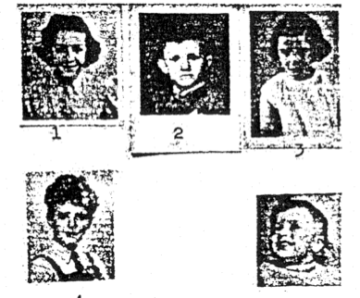

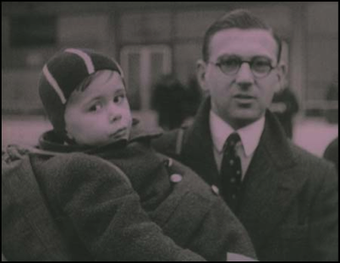

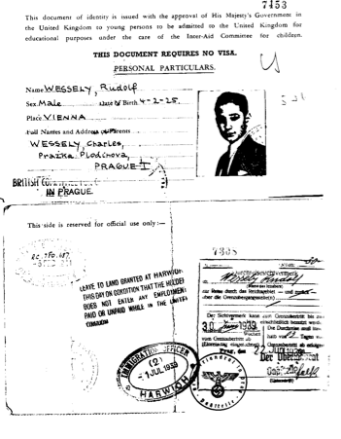

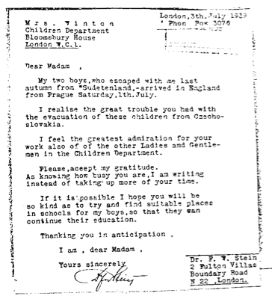

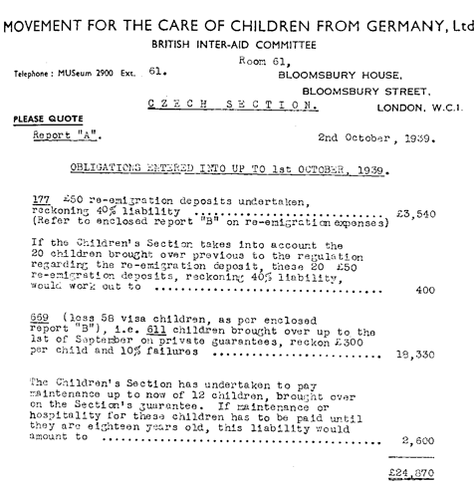

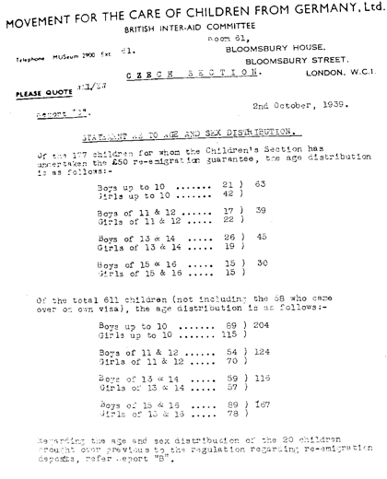

Further Inquiry Questions

What are values? How are values shaped by our upbringing? Should people change to fit in to their new country? How are cultures similar? How are they different? How can they be celebrated? How can we respect other cultures? Does anyone have the right to decide who lives where? What do we need to visit other countries? What information do we need to have?

What happens to children living with war? What is our countries responsibility to those children? What is our individual responsibility to children in other countries? What laws protect children? What is the Convention on the Rights of the Child?

What is “Kindertransport”? Who is Nicholas? Why were children chosen? Why did the parents send them away? Where did the children go? Who looked after the children? How did they travel to England? Why did Nicholas get involved?

What happened in the Second World War? What happened in the build up to the war? What was the war about? Why were the Jewish community persecuted? How were they persecuted? Should the children have returned ‘home’ after the war? Should the parents have sent them? Should countries help other countries? Should anyone in danger be allowed in to a safe country? How do we judge what is dangerous? Did the parents make the ‘right’ choice? Is there a ‘right’ choice? Could you send your child away? Would you tell them why they were being sent?

Should Nicholas have intervened? What laws are there regarding migration? Are these laws different for people from war torn countries? Should they be different for adults and children? What changed for these children? What changed for the local communities that took these children in? How was the Jewish community in Prague affected by the war? What happened to the families after the war?

How did the world change because of the war? How did the war shape of views and values today? What is ‘home’?

Further Lines of Investigation

**Countries**

• Where is Prague? What country is it in? Where is Berlin? What country is it in?

• What is was Prague/Berlin like in WW2? What is it like now? What is different?

• What food would they have eaten? Clothes? Daily life? Religion? Homes? Work? Weather? Celebrations?

• How would things have been different here? What would you miss if you lived in another country?

• Where have you travelled? How did you travel? Who has been the furthest? Has anyone been born in another country?

* What makes you a British citizen? What does that mean? What is a passport? How do we use one? Why do we need one?

**Memorials**

• What is a memorial? Why do people make them? Who are they for? Are they important? Why do we need to remember parts of history?

• Are there any in our local area? Who are they for? How should we treat memorials?

• What other memorials are there? Which is the biggest? Which is the smallest? Where are they? Do any special events happen around

them?

• What is the Jewish memorial? Where is it? What does it look like? When was it built? Who designed it? Why is it so big? Why has it got

lots of blocks? How does it represent the Jewish people? Why is it only for the Jewish people? Why is it in Berlin? What does it make you think of? How does it make you feel?

* • How would you create a memorial for an event? What would you want people to remember? How would you want people to feel? How would you design it? What would you make it out of? How big would it be? Where would you put it?

**Memorials**

• What is a memorial? Why do people make them? Who are they for? Are they important? Why do we need to remember parts of history?

• Are there any in our local area? Who are they for? How should we treat memorials?

• What other memorials are there? Which is the biggest? Which is the smallest? Where are they? Do any special events happen around

them?

• What is the Jewish memorial? Where is it? What does it look like? When was it built? Who designed it? Why is it so big? Why has it got

lots of blocks? How does it represent the Jewish people? Why is it only for the Jewish people? Why is it in Berlin? What does it make you think of? How does it make you feel?

* • How would you create a memorial for an event? What would you want people to remember? How would you want people to feel? How would you design it? What would you make it out of? How big would it be? Where would you put it?

**Foster families**

* What is fostering? Why do we have it? How is it different to adoption? What responsibility does a foster carer have to a child?
* How did Nicholas find foster families? Where did they come from? how did her advertise for them? How many families did he find?
* Did siblings stay together? Is this important?
* How old were the children? Did they remember their home? Did they remember their parents? How long did they stay with their foster families? Did they keep their names? Are ames important? What is identity?

• What makes a good foster family? How do you choose a foster family? How do a foster family choose a child? Why would a family foster children? Why would they foster children from another country? Another culture? What questions would you ask to find out if someone would make

a good foster carer? What qualities would you want them to have?

• What would the children have found difficult about going to a foster family? What would the foster family find challenging?

• How would you prepare your home for a foster child? What would they need? How would you welcome them? What information would

you need to tell them? How do you help them with the different culture? How do you find out about their culture?

**Language**

• What language do they speak in Prague? How do you say hello in Czech?

• What is it like to be somewhere when you don’t speak the language? How do you communicate with others when you cant speak the

language? Why is gesture important? Why is facial expression important?

• What key words/phrases would you teach the evacuee’s? Why are these important? How would you teach these words to them?

What words can you learn in Czech/German that would be useful if you were evacuated there?

**Bravery**

• What is bravery? What is a hero? Are all heros physically strong? Do all heros have superpowers? Can anyone be a hero?

• Can heros be scared? What is fear? What makes people scared? Can you be scared and brave at the same time?

• What makes someone a hero?

What is the bravest thing you have done?

**Family**

• What is a home? Who lives in your home? What is special about your home? What makes you feel safe at home? What does your home

look like? Have you always lived there? Have you ever moved? What is moving like?

• Who is in your family? What is a family? What different types of families are there?

Have any of your family moved country? Have any of your family been an evacuee?

**Countries**

• Where is Prague? What country is it in? Where is Berlin? What country is it in?

• What is was Prague/Berlin like in WW2? What is it like now? What is different?

• What food would they have eaten? Clothes? Daily life? Religion? Homes? Work? Weather? Celebrations?

• How would things have been different here? What would you miss if you lived in another country?

• Where have you travelled? How did you travel? Who has been the furthest? Has anyone been born in another country?

* What makes you a British citizen? What does that mean? What is a passport? How do we use one? Why do we need one?