Vikings

Expert Frame

Team: Scriptwriters
Client: BBC
Commission: To write the outline of a script for the BBC telling the story of a Viking burial site discovered recently in rural England.

Opening Sequence

Resources:
- Board to draw the hill on
- Strips of paper to use in Step 2
- ‘Archaeologists’ notes’ from Step 3 printed out for students (see resources list below)
- Topic books and other resources for Step 4
- Commission letter from BBC (see resources)

Step 1

This step is an introduction to the context told in the style of a storyteller. The teacher will stop when needed to answer questions and check for understanding.

1. The students are sat together; the teacher stands at the board and begins:
2. “The story started early one morning. There was a hill (she draws the hill on the board) and a helicopter (she signals the helicopter with her hand). The helicopter was flying low taking photographs of the fields; they were using a new kind of technology, one that could give them an idea if there was something man-made under the ground.”
3. “They were particularly interested in these fields because there were local legends that told of an ancient king. A king of great wealth and renown, who came from over the sea as a conqueror and ruled this part of the country for many years.”
4. “The people in the helicopter were archaeologists from the local museum and what they found made them famous.”
5. “They found it early on the second day. They’d been surveying the surrounding fields and had found some interesting structures – a long wall, some buildings of various sizes, and what they thought might be a tower – then they turned their attention to the hill.”
6. “They flew the helicopter over the top and almost immediately realised there was something of great interest inside.” (The teacher returns to the board and draws a rectangle inside the hill). She looks at the class:
7. “What do you make of that?” She listens to the students’ answers, nodding and asking for more detail. She is not looking for the right answer, just opening up the story to conversation. After a while she moves on:
8. “In the afternoon they found the passageway.” (She draws it on the board, connecting the rectangle to the edge of the hill. “And contacted the museum immediately.” (The teacher picks up an imaginary phone):
9. “We think we’ve found it. It’s inside the hill, there’s what looks like a burial chamber and a passageway leading in. With your permission we’d like to start excavating tomorrow.” (The teacher nods) “Great, I’ll tell the others.”
10. “The next day the archaeologists returned to the hill, this time on foot, carrying their equipment. They set up their tents and waited for the digger. It arrived mid-morning and by the end of the afternoon they had uncovered the stone doorway to the tomb.”
11. “The doorway they found was decorated in ancient runes. One of the archaeologists translated the message…”

Step 2

In this step the teacher invites the students to join in with the invention of the story by creating the messages written on the door of the barrow.

1. “Let’s stop the story there for a moment. What do you make of what’s happening so far? Does this remind you of anything?”
2. The teacher gives the students time to talk; she is not looking for an answer.
3. “What do you think the runes will say?”
4. “Why don’t you grab a piece of paper, write a brief sentence and we’ll see what we get.”
5. The teacher supports those that need it and then collects the sentences together. After putting them into an order, she begins:
6. “The archaeologist ran her hands down the stone carvings, her lips moving as she translated the ancient words…” [The teacher reads out the students’ suggestions, leaving out those that don’t sound authentic].

Step 3

In this step the students find out what is inside the barrow through information cards created in advance.

1. “Slowly and carefully the archaeologists lifted the stone door from the entrance to the tunnel and shone their torches inside. What they found was remarkable.”
2. “I’ll hand out these reports written by the archaeologists so you can see…” [The teacher passes round notes – see resources below].
3. The teacher gives the students time to read the notes and talk amongst themselves.

Step 4

In this step the students draw the objects in the ship using topic books and other resources for information.

- “It's not easy to see from the pictures in the archaeologists’ notes what the artefacts looked like in detail and later on in the story this is going to be important. I suggest we stop at this point and spend some time drawing these objects paying close attention to their design and decoration. I found these topic books which you might find useful and some pictures off the Internet.
2. The teacher hands out paper for drawing with and the resources needed by the students to research.
3. As the students work the teacher offers support.
4. She tells the students it doesn’t matter if more than one person decides to draw the same object: “Don’t worry if we have more than one version of the same object, we are just collecting ideas at the moment.”

Step 5

In this step the students imagine why these objects in particular were buried along with the bodies of the people.

1. “As you work can you please invent a reason why your object was buried in the tomb, what is its relevance and importance to the people there? Is it a gift to those buried, an offering to the gods, something for them to use in the afterlife, or something precious that they once owned?”
2. “Once you have an idea can you please write it on the back of your picture so you can read it.”

Step 6

In this step the students imagine the burial ceremony, who was there and why they brought these objects to be placed in the boat.

1. The teacher asks the students to come together in a circle leaving their pictures on the table.
2. “I wonder what the ceremony was like? Do you think it would have been held during the daytime or at night? What sounds would there have been? What light? Did the people there arrive separately or did they come together in a procession?”
3. The teacher listens to the answers to these questions and then asks the students to ‘reconstruct’ the ceremony. Something like:
4. “So we’re saying it was at night and the people arrived carrying torches and walking in a line to the sound of a drum?”
5. “How did the drum sound?” [The teacher guides the students to make a rhythm.]
6. “What about the procession, was it single file or double? Why don’t we see it? Could you stand up and get into a line like the one that night?”
7. The teacher helps the students get organised and to think about how the line was organised. “Do you think it mattered where people stood? Would those with power and influence stand at the back or at the front? If you are someone from the aristocracy can you make you way to the front of the line. What about warriors, did they walk in the same line or come in a separate line? Did they carry their weapons do you think…” [And so on. In this way the teacher supports the students to step into the story and take on roles.]
8. “Shall we see what this ceremony looks like? We’ll need the sound of the drums. I can provide those. Ready?” [The teacher makes the sound of the drums and the students walk slowly in lines carrying the objects they have brought for the ceremony] Note: They are not carrying the pictures themselves, but an imaginary object of the shape and size of the object they are bringing to the burial.
9. The teacher narrates: “The cold night air was interrupted by the sound of a single drum… boom, boom, boom… followed by two slow moving lines of torches… boom, boom, boom… the mourners, carrying their gifts, formed a circle around the burial ship containing the body of their chieftain and his retinue…”
10. The teacher continues: “What have you brought here this evening to lay beside our great king as he travels to Valhalla?” [She stretches out her hand to invite the mourners to step forward one at a time and place their gift in the boat.] Note: If the students need help with this transition the teacher can stop the fiction to give them guidance: “Let’s stop the story for the moment. When I say, ‘What have you brought…?’ That’s your cue! You need to speak up, one at a time, ‘I have brought a sword, forged of iron and inscribed with his name.’ and place the object in the boat. And then the next person and then the next, and so on until everyone has spoken. Don’t worry if two people speak at once, just try again. Okay, are we ready? Let’s go…

This continues until everyone has laid down their gifts.

Step 7

In this step the class reflect on what this might tell them about Viking culture, their beliefs, and values.

1. [The teacher stands with the students looking at the objects laid on the floor] “Why do you suppose they buried their dead with objects like these? And why in a boat?”
2. There follows a conversation guided by the teacher’s questioning. As the inquiry develops she asks the students to think about the context and it’s meaning. For example:
- “Many of these objects are personal to the people in the tomb. Is that significant do you think?”
- “And why a boat? This is not a boat that would ever sail on the ocean, it is too flimsy, so why bury the king in it?”
- “What do you make of the animals and the way they are buried?”
- “It seems quite different to a Christian burial don’t you think?”
- “What would you say was important to these people? I mean metal was a very rare commodity, so burying some much of it in the ground where it would never be used must tell us something about what they believed was important?”
- “If you were to go away after today and tell someone about the Vikings, something important, what would it be?”
- And so on.

Step 8

In this step the students are cast as a scriptwriters commissioned by the BBC to write an outline for a documentary on the Vikings and the archaeologists discovery of the tomb..

1. The teacher sits with the students: “What do you think was the most disturbing thing about what the archaeologists found in the tomb?”
2. There follows a short discussion.
3. “Do you think any of these things would be a good way to start a TV programme on this discovery? Or do you think it would be better to start at the beginning with film of the helicopter flying over the fields?”
4. “How much do you think the documentary should tell people about the Vikings and their culture?”
5. “And what about the burial, do you think the documentary should include a reconstruction of the night of the burial, using actors and such like?”
6. “If we were people asked by the BBC to advice them on making a documentary of this kind, what sorts of things do you think should be included?”
7. It might make sense to make a list…”

Step 9

In this step the students are given the task of making a list of things that should be included in the documentary. The teacher gives them paper and access to the topic box, other resources, and the artefacts they created earlier.

As they work she moves round the room supporting those that need it and collecting ideas. Some of these she writes on the board under various headings, such as: ‘background history’, ‘reconstructions’, discovery of the tomb’, ‘work of archaeologists’, ‘artefacts’, etc.

Step 10

In this step the students meet a representative from the BBC, ask them questions, and talk to them about their ideas for the documentary.

1. “If we were the people advising the BBC and one of their producers was coming to meet us, how much of this do you think we should tell them, all of it or just some of it? Are some aspects more important than others?”
2. “Where would we meet them do you think? Have we got a meeting room for such things? How is it organised, does it have a table, chairs, other furniture?”
3. “Why don’t we move the chairs around to set the room up as we want it?” [Students work on creating the space with the teachers support. Depending on space.]
4. [When they are ready the teacher moves a chair to the front] “We’re nearly ready. I’m going to come into the story in a moment as a producer from the BBC, when I sit in this chair the meeting will start and we’ll go on for a long as we can. Are you ready?”
5. [The teacher sits in the chair] “Thank you for meeting me this morning, I know you’ve already started working on ideas for the programme and I’m very interested to hear what you’ve done so far. Who would like to start?”
6. [The teacher and students talk now inside the fiction for as long as needed. If the students get stuck, the teacher stands up and comes out of the story to help them.] “I’ll just come out of the story for a moment. If you all talk at once it is very difficult to make this work, this is not going to be like a classroom where you put your hand up and I say who talks, you’re going to need to work out this for yourselves. Shall we have another go?” [The teacher sits back down] “I’m sorry can I hear that last point again?” Etc.

Step 11

The producer from the BBC concludes the meeting.

1. “This meeting has been very productive, thank you. We would certainly like to go ahead and work with you on this project and I look forward to seeing how your ideas develop. I’ll be sending you a conformation letter before the end of the week, detailing exactly what we would like you to do, but before I go are there any questions you would like to ask, either about the documentary, the work, or the discovery of the tomb?”

Step 12

The commission arrives in the form of a letter.

- [The teacher sits with the students in the team’s meeting room, holding a letter from the BBC which she has prepared in advance.] “Well it’s arrived. Let’s see what it says…” [She reads out the letter (see resources) and answers the team’s questions.
- There follows a discussion here around the work to be done and how it is going to be organised.

Step 13

The team start work on the commission organised with the help of the teacher.

Note: This is the end of the opening sequence. From here on the teacher guides the students through the commission, making links to the curriculum. At various points the class step back into the past to explore the lives of the Vikings. The teacher keeps a close eye on the tensions so that the work doesn't become a ‘topic’.

Links

- https://vikingsociety.wikispaces.com/Death+and+Funeral+Rites
- https://blog.britishmuseum.org/2014/04/16/the-viking-way-of-death/

Resources
- Commission letter from BBC
- Archaeologists’ notes
- An artist’s impression of the funeral boat
- A photograph of two ‘sorceresses staffs.

BBC Broadcasting House
Portland Place
London
W1A 1AA

History Research Team
Martineau Lane
London
EC2Y 5HN

12 September 2106

Dear History Research Team

Thank you for a very productive meeting last Tuesday. I was particularly interested in… [insert details here]

As I mentioned at the meeting we would like to go ahead and commission you to work with us on the production of a documentary on this exciting discovery. Specifically this would involve your team in the following tasks: [insert details here]

I’m looking forward to seeing how your work progresses and would like to visit you again on [insert date] to discuss how things are moving on.

In the meantime please do not hesitate to contact me if you have any further questions or if you would like to make direct contact with the archaeology team who made the discovery.

Yours sincerely

G. Hirste, producer

Archaeologists’ notes

These details can be adapted and edited as needed. They are taken from this website with the kind permission of the author: https://blog.britishmuseum.org/2014/04/16/the-viking-way-of-death/

1. There are two grave-sites inside the barrow. The first seems at first to be a relatively simple affair. In the middle of the 9th century a man of indeterminate age was buried on his left side, probably dressed in a cloak because a brooch was found at his shoulder. His chest was pressed up against a large stone, and his body had been covered from the waist down with a cloth of very fine quality, drawn up like a blanket over his legs. With him were a handful of objects: two knives, a fire steel and two flints, a whetstone, some fragments of a soapstone bowl and what the excavators called an ‘egg-shaped stone’. Little in this is particularly exciting, though even this meagre grave has its own character and individualism, everything in it being there for a reason. However, it is what happened next that is remarkable.

2. Several decades later in the early 900s, an 8.5m-long boat was placed exactly on top of the dead man, its keel aligned precisely along the axis of his grave (which tells us that its location was remembered). Inside the boat were the bodies of four people: a man, two women and an infant, together with a number of animals. Around and above the bodies, laid out together with them or deposited above them as the boat was filled with earth, were masses of objects.

3. In the prow a man and a woman lay apparently on blankets covering the decking. The woman was aged about 45-50 when she died, arranged on her back with her right hand on her breast, ankles crossed and her feet pointing into the prow. Her head was resting on a stone, like a pillow. She was expensively dressed, her clothes held together with silver jewellery. From her belt hung a knife and a key. To her immediate right was a bucket. Balanced across her knees, a weaving sword.

A baby was wrapped in the woman’s dress, bundled at her hip with her left hand resting on its head.

4. Lying head to head with the woman, arranged symmetrically with his feet pointing to the stern, was a man of unknown age. He had been placed slightly twisted, on his back but with legs flexed and bent to one side at the waist. Laid out around him were weapons: two axes, of which one was an antique; a throwing spear; a sheathed sword, its point precisely at his head, with two knives and a whetstone next to it; a shield (two more lay nearby); a quiver of arrows and therefore probably also a bow. A silver arm-ring lay above him. On his midriff lay an inverted frying pan. On the sword scabbard two spindle whorls had been carefully placed. A pot of German manufacture had been smashed and its pieces scattered over the man’s body along with three glass beads, near a soapstone vessel. Two more of the latter were deposited at the man’s feet. An iron dog chain was draped next to him, with a sickle somewhere nearby.

5. Amidships, a bridled horse had been killed and laid on the deck. Its throat was probably cut, and it seems to have been decapitated and roughly dismembered, its limbs and body parts then placed back in approximately their anatomical positions. A single spur was placed on the mangled corpse.

6. In the stern of the boat was a second woman, apparently buried sitting up, either in a chair or hunched up against the rising end of the vessel. From her location and posture it is possible that the steering oar of the boat was resting in her hands. A whetstone and a bridle-bit leant against her feet, which touched the carcass of the horse. She was well-dressed in high fashion. Behind her was a shield. To her right, resting on the deck, another of those enigmatic ‘egg-shaped stones’ and a weaving sword of iron. To her left, an unusual iron staff pinned down under a large rock. Somewhere near her was an axe. In the woman’s lap was an imported bowl of bronze that had been scratched with runes, i muntlauku, ‘.. The bowl contained some unidentified little metal objects, and the severed head of a dog. Its body lay across the woman’s feet. One pair of its legs, perhaps detached, lay a little below the torso; the other legs were missing. Marks on the bones suggest crude carving of the flesh before the ragged skeleton was reassembled. Around the woman were also found fragments of wood and bark, pieces of sheet iron and objects of copper alloy; we do not know what they were.

The iron staff might offer a small clue to the nature of the dead steerswoman, as it is of a kind identified as a tool of the sorceresses called a völur, and other female magic-workers, who feature extensively in the Icelandic sagas.

7. The whole burial was covered with earth and complex stone constructions, building up to a low mound. We also found patches of cremated bone and wood mixed here and there in the deposit, hinting at further rituals about which we know nothing.

In all of this, we noted the detail, the precision, the deliberate choice and positioning of objects. The treatment of these Viking-Age dead is eloquent in its sheer specificity.

So what were they doing? A burial of four people in a boat, itself placed on top of another grave, a few decades old. Were the man and woman a couple, with their child? Or were they unrelated? Who was the woman sitting in the stern, apparently some kind of witch? Did they all die together, either violently or through illness? Was one or more of them killed to accompany the others in death? Whose were the boat and the animals, or did they belong to none of the dead? What do the objects mean, and would a contemporary understanding of them even approximate to our own? What connection did all of this have with the man under the keel? One thing is for certain, there are more questions here than answers.

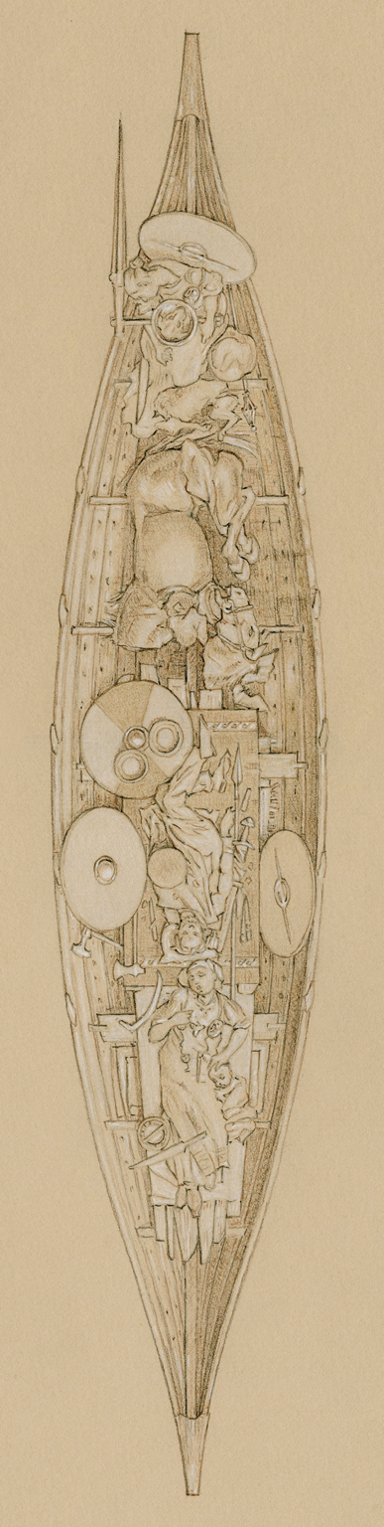
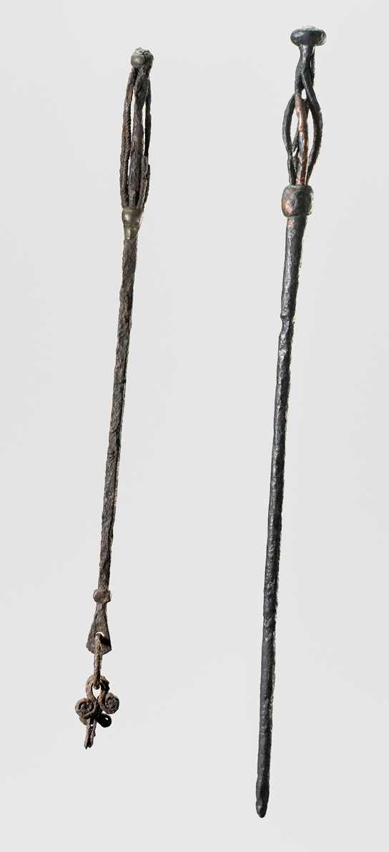
Objects of this type have been interpreted as staffs used by Viking sorceresses.

